9/30/2023
Douglas Ettinger
Ettingerjournals.com
Compilation of Astrophysics Quizzes Published by an Astronomy Monthly Newsletter
By Douglas B. Ettinger, Amateur Astrophysicist and Member of Amateur Astronomers Association of Pittsburgh (AAAP)

Compilation of Astrophysics Quizzes used in an Astronomy Club Monthly Newsletter:
Astrophysics Quiz No. 1
Let’s check your knowledge of the most popular or consensus ideas in astrophysics:
- How did planet Earth receive its water?
- Comets disrupted from the Kuiper Belt.
- Asteroids from the Main Belt.
- Outgassing before the T-Tauri phase of the Sun.
- Disruption theory of Earth being displaced from the Snow Line.
- Volcanism after the Sun’s T-Tauri phase.
- What caused the Main Belt of asteroids?
- Collisions of celestial bodies between Mars and Jupiter.
- Gravitational disturbances of nearby massive Jupiter.
- Gravitational resonances set up by the conjunctions of Jupiter and Saturn.
- Uncongealed dust and planetesimals left over from the original nebular cloud.
- What caused the cratering of the celestial bodies found in the inner solar system?
- Arbitrary asteroids and comets for the past 4.6 billion years.
- Mostly a disturbance of the Late Heavy Bombardment (LHB).
- High energy electromagnetic strikes of plasma due to close encounters.
- Why did the Late Heavy Bombardment of 3.9 billion years ago occur?
- Outward migration of the outer planets disturbed the Kuiper Belt Objects.
- The inward migration of Jupiter and Saturn disturbed the Asteroid Belt.
- A disruption theory that predicts a major collision of two large bodies.
The answers are controversial, but the experts have chosen one or more of the available choices as their current best predictions. I hope you enjoy this exercise in astrophysics. It is fun to guess or propose reasons for what astronomers see in the sky. I can promise you many more probing questions. And expect these answers to possibly change over time.
Doug Ettinger, amateur astrophysicist
ANSWERS: 1.B; 2.C; 3.B; 4.A

Astrophysics Quiz No. 2 The Strangeness of Planetary Surface Features
Let’s explore some of the well-known major surface features of celestial bodies in the solar system. Try to determine the reasons for their occurrence given by the experts.
Please keep in mind that the correct answer is about the current thinking which sometimes lags newer discoveries by years or decades.
- What caused the persistent Great Red Spot as large as three Earths on Jupiter?
- The mere randomness of anticyclonic storms on the surface.
- The eruption of reddish material from the interior.
- A rogue, minor planet strikes and punctures the icy layers beneath the gaseous surface thereby creating a continuous sunken location for a storm center.
- Consensus science and NASA have yet to claim a reason for its existence although the collision of Comet Shoemake-Levy 9 does give some clues.
- What created the largest canyon in the solar system, Valles Marineris, on Mars? This canyon measures 2500 miles long, about 120 miles wide, and 23,000 feet deep.
- A tectonic fault was created by the raising of the crust due to nearby large volcanoes in the Tharsis region of Mars.
- Due to crustal shrinkage, a rift opened and spread apart the crust like the Atlantic Ocean rift on Earth.
- Both a tectonic crack and erosion by ancient water caused this immense canyon.
- A huge high-energy plasma discharge sputtered across the surface as a close encounter with a rogue planet passed and unleashed its stored electrical power.
- How did Earth come by a raised landmass that covers about ¼ of the surface and was initially concentrated into a single area called the Supercontinent? No other planet has this uniqueness. This creation gave Earth two different crustal compositions: granitic for the continental and basaltic for the oceanic crusts which include extensive moving tectonics plates and continental drift.
- A frozen rogue planet struck a very young molten Earth and penetrated the Earth’s mantle; its mixture of mantles created a raised caldera above the original oceanic crust. The mixture of the two mantles caused a granitic crust different from the existing basaltic crust.
- Plumes of interior differentiated lava floated slowly to the surface from the liquid core supposedly creating geological hot spots such as the Hawaiian Islands that occur even today.
- Geophysicists are still puzzled about the cause but provide interesting, unsettled hypotheses.
- Why does Jupiter’s closest moon, Io, show evidence of volcanic plumes?
- Jupiter’s huge gravity field creates tidal forces on Io’s surface causing random volcanoes of molten sulfur.
- There are new evidence Io’s volcanoes move on the surface thus creating the suspicion that moving high energy electric arc discharging is occurring along dark mode plasma currents coming from Jupiter’s poles.
Presented by Doug Ettinger, an amateur astrophysicist.
ANSWERS: 1.D; 2.C; 3.C; 4.A

Astrophysics Quiz No. 3: The Feared Comets and Asteroids
Let’s review some facts and commentary about comets and asteroids.
- What are the main differences between comets and asteroids?
- Asteroids are generally rocky bodies whereas comets are generally icy volatile objects.
- Asteroids have more circular orbits and comets have more elliptical orbits.
- Comets are generally smaller than asteroids.
- Comets have tails and comas, unlike asteroids.
- Comets have a lifetime of millions of years whereas asteroids may have as many as billions of years.
- True or False – 1F, 2T, 3F, 4F, 5F.
- True or False -- 1F, 2F, 3T, 4F, 5T.
- True or False – 1F, 2T, 3F, 4T, 5T.
- What are the names of some likely groupings for asteroids?
- The Main Belt
- Trojan Asteroids of the Outer Planets
- Near Earth Objects (NEOs)
- Kuiper Belts Objects (KBOs)
- Irregular moons of Jupiter and Saturn
- Moons of Mars.
A. 1, 2, 3, 4.
B. 1, 2, 3, 4, 5.
C. 1, 2, 3, 5, 6.
D. 1, 2, 5, 6.
3. What is the current consensus origin of the comets?
A. Comets come from the disturbance of the Kuiper Belt Objects by the early migrating planets.
B. Comets come from the Oort Cloud almost two light years away that are occasionally disturbed by a passing star.
C. They are the results of collisions by celestial bodies within the solar system.
D. Asteroids become perturbed and go into more elliptical orbits taking them closer to the Sun.
E. Only B, C, and D.
4. Where do NASA and academia currently believe Earth’s water came from after the Sun’s T-Tauri phase?
A. From comets and the outer Kuiper Belt Objects (KBOs).
B. From early planetesimals that resemble today’s asteroids.
C. From late outgassing of Earth’s deep mantle.
D. From both very late outgassing of the mantle and bombardment of chondrite asteroids.
Presented by Doug Ettinger, an amateur astrophysicist (dougettinger@verizon.net)
ANSWERS: 1. C; 2. C; 3. E; 4. D.

Astrophysics Quiz No. 4: The Moon Enigma
What do we know about the ‘Moon Enigma’? Earth’s Moon cannot be explained or modeled using the favored nebular hypothesis for the formation of the solar system where a dust cloud eventually forms rings of planetesimals close to a forming star that then create orbiting planets that then form moons the same way.
1. The Earth-to-Moon mass ratio is ____________times more than all the other primary moons in the solar system causing suspicions that our Moon has a unique source.
A. 2 to 4. B. 5 to 10. C. 10 to 50. D. 100 to 1000.
2. The Moon-to-Earth radius ratio is almost ___________ times larger than all the other primary moon-to-planet radius ratios in the solar system.
A. 100. B. 50. C. 20. D. 10.
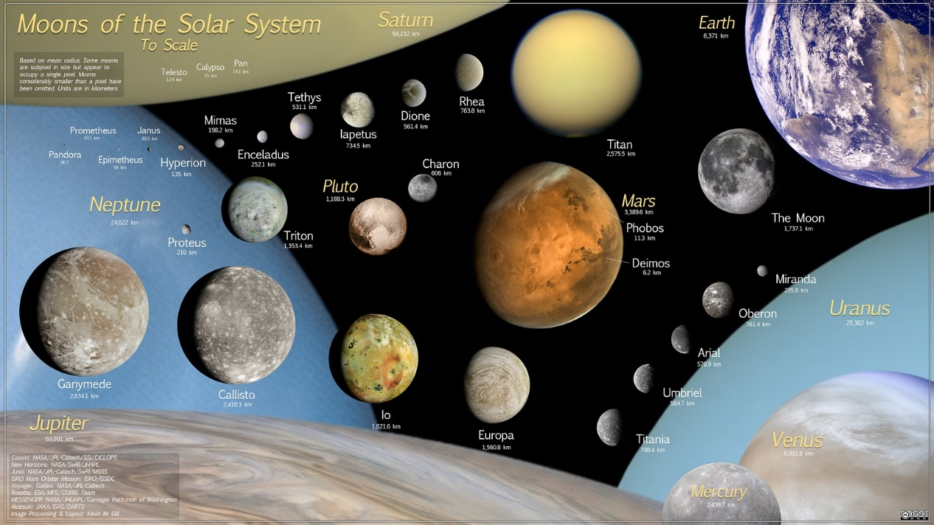
Comparative sizes of solar system moons and planets.
3. Gravity forces are computed from Newton's famous equation: f = (G x M x m)/d² and the "Tug of War" ratio between the moon’s planet and the Sun is f_{PLANET} / f_{SUN}. Of all the significant satellites, only the Moon has a ratio of __________.
A. Less than 2. B. Equal to 1.0. C. Less than 0.5. D. Comparable to the other moons at 30 or more.
4. The lunar orbital plane is _________ the ecliptic plane and _____ the Earth’s equator that demonstrates a poor direct connection in the Moon’s and Earth’s formation.
A. the same as / 23 degrees different from. B. 5.1 degrees different from / 28.5 degrees different from. C. zero to / the same as.
5. The Moon's orbit is everywhere concave toward the Sun or always falling toward the Sun; all other major satellites without exception fall away from the Sun through part of their orbits being caught by the greater gravity force of their parent planet.
A. True. B. False.
6. How does NASA with great difficulty, thus far, resolve the ‘Moon Enigma’?
A. Using a binary model where the parent planet ejects a part of itself into orbit.
B. Using a capture method where a near-passing body is snared by the planet’s gravity.
C. Using a combination capture/collision mode where a glancing body remains captured.
D. By a more direct collision where the mantles vaporize and then reform as the Moon above the Roche limit and for the remaining material returning to Earth.
E. By Earth disrupted from another outer orbit and then developing a new orbit very close to the existing terrestrial planet, the Moon, allowing enough time for the two planets to share a synchronized orbit.
7. Why have the Moon’s mares remained molten from its formation close to 4.5 billion years until almost 3 billion years ago?
A. The Late Heavy Bombardment (LHB) period pelted the Moon continuously between 3.9 to 3.0 billion years ago.
B. The Moon’s lack of atmosphere prevented early asteroids from burning up.
C. NASA’s Apollo Missions and analyses have not yet resolved this question.
D. The Earth was displaced to the Moon’s orbit and brought collisional debris that took the Moon 900 million years to sweep up causing its surface to partially remelt after each impact.
ANSWERS: 1. D; 2. D; 3. C; 4. B; 5. A; 6. D; 7. C.
Presented by Doug Ettinger, an amateur astrophysicist (dougettinger@verizon.net)

Astrophysics Quiz No. 5: Mystery of the Missing Planet
Let’s search for answers to why liquid water formed minerals such as carbonates (minerals having the ion CO2 ) in outer space without Earth being present. The evidence shows these hydrated minerals occurred about 4.5 billion years ago, but Earth at one AU was supposed to have all its volatiles boiled away during its birth around that same time by the hot T-Tauri phase of the proto-Sun. The evidence is found in dating meteorites that have carbonates which can be only formed in the presence of water, solid metal elements, and carbon dioxide.
1. What do carbonates like limestone and dolomite need to form in primeval times?
A. A cool solid, rocky surface.
B. Thick enough atmosphere to create enough pressure to condense water on a dry surface.
C. A warm, preferably shallow liquid ocean with photosynthetic organisms.
D. A large enough planet that provides an environment to gravitationally hold an atmosphere but be far enough away from a proto star so that water remains in a liquid form.
E. An appreciable outgassed and retained concentration of CO2 in the atmosphere.
F. Metals such as calcium, magnesium, iron, and sodium found in the planet’s crust.
G. All the above.
H. Only items A, B, and E.
2. The big question is where and what type of planet with some of the above-described properties exist before 4.5 billion years ago close to the time of the birth of the solar system with all its planets.
A. A rocky terrestrial inner planet.
B. A moon of one of the outer planets or a Kuiper Belt object.
C. A planet that outgassed CO2 which did not boil off because it was far enough away from the hot corona of the proto-Sun.
D. A recently born planet that had sufficient time to form an early crust.
E. A terrestrial planet that existed close to the primeval snowline making liquid water possible.
F. A planet inside the orbit of Mars.
G. All of the above, except D and E.
H. All of the above, except B and F.
3. What possible evidence is available to demonstrate that such a planet with carbonates on its surface existed 4.5 to 4.2 billion years ago?
A. The Kuiper Belt Objects and comets.
B. The Main Belt of asteroids that have other minerals made in the presence of water.
C. Asteroids with the appearance of rocky debris produced by high temperatures of a large collision penetrating and dispersing a solid, igneous crust and liquid mantle.
D. An existing watery Earth that was disrupted from its original orbit near the primeval snowline.
E. Only the above items B, C, and D.
4. What evidence do asteroids provide to demonstrate that they consist of a primitive rocky, wet crust that was smashed and scattered into space?
A. Asteroids have families of different compositions and densities that are found in sub-belts which may represent the crusts and mantles of two colliding planets.
B. Asteroids are always irregular in shape except for Ceres and Vesta.
C. Many asteroids have their own satellites.
D. Small amounts of hydrated minerals are found in asteroids that have been examined by space probes. Also, minerals requiring high temperatures are found on these cold asteroids.
E. All of the above.
F. Only A and B.
5. Why are there doubts that a planet ever existed in the asteroid belt?
A. The total mass of surveyed asteroids is less than one small moon.
B. The proposed impacted planet is missing.
C. The gravitational disturbance of nearby Jupiter helps to explain that these so-called primeval planetesimals were unable to form a planet.
D. The Titus-Bode theory does not predict a planet for this orbital location.
E. A, B, and C.
F. C and D.
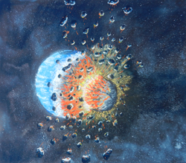
Drawing depicting a young, water-covered fragile crust of young
Earth struck by a smaller body.
Presented by Doug Ettinger, an amateur astrophysicist (dougettinger@verizon.net)
ANSWERS: 1. G; 2. H; 3. E; 4. E; 5. E.

Astrophysics Quiz No. 6: Who are Stickmen? (not be confused with Zubens)
The most famous petroglyph found worldwide is the stickman. These primitive carvings and etchings on rock faces look like a stick man that a child may draw to represent a humanoid. Its arms are held upward, and its legs are spread apart. Why did primitive man draw these eerie creatures more than 10,000 years ago? We will search astrophysics for an answer.
1. What proposal for stickman is not given by archeologists, anthropologists, and other scientists?
A. The imaginations of stone age peoples that were coincidentally extremely similar in all countries in the lower latitudes of the world.
B. Real extinct giants that walked the Earth in ancient times.
C. Large bolts of lightning that lit the low-lying cloud cover and struck the ground.
D. High-energy sustained plasma discharges that move across the surface sputtering rock upward.
E. An icon of some unknown worldwide ancient religion.
2. How are stickmen proposed to be created or even proven in the scientific world?
A. The phenomena of lightning from cloud to land provide an analog at a much smaller scale making the idea of sustained plasma strikes plausible.
B. Plasma laboratories can duplicate these likenesses including the portrayal of multi-arms and cyclotron radiation. The revealing of cyclotron radiation created in the laboratory is the same as the drawn circles along either side and below the raised arms of many petroglyph stickmen.
C. Landscapes, especially those found in the Southwest, like buttes, mesas, and unusually distinct layered gravel sediments indicate the destructive force of plasma discharges traveling along the ground, lifting the surface, and depositing their sputtered debris.
D. All of the above.
E. Only A and B.
3. If such continuous high-energy plasma came from the heavens to produce these stickmen monsters, then what is the best or most accepted answer by science?
A. The source is undetermined, and high-energy plasma via stickmen is mostly denied in current academic circles even though laboratory experiments show a possible answer.
B. A close encounter with a celestial body exchanged electrical energy and created a charged atmosphere.
C. Volcanoes and rifts emitted dust and gases that created electrical charges in the atmosphere.
D. One possible but improbable source is a huge coronal mass ejection (CME) from the Sun that hits Earth and surrounds and shrinks its ionosphere. The charge in this magnetized plasma acts like a capacitor with the two plates being the lowered ionosphere and Earth’s surface with the atmosphere acting as the dielectric breakdown between the plates.
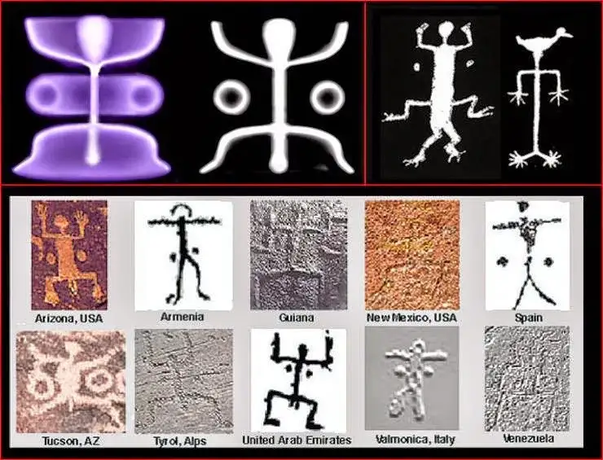
Worldwide ancient stickman (also called squatter man) with experimental plasma lab results shown in the upper lefthand corner. How can scientists realistically call these illustrations a coincidence?
Presented by Doug Ettinger, amateur astrophysicist (dougettinger@verizon.net)
ANSWERS: 1. D; 2. D; 3. A.

Astrophysics Quiz No. 7: Can the Sun be Both Guardian and Destroyer?
The Sun provides heat and light for life on Earth but also can destroy by a little-known process called coronal mass ejection (CME). Let’s learn about its destructive nature.
1. Choose what is false about CMEs:
A. Electrically charged particles that escape the Sun in the plasma dark mode.
B. Many of these emissions move outward along the ecliptic toward the planets.
C. These retained magnetized clouds cause geomagnetic storms and dramatic auroral displays.
D. These CMEs travel relatively slowly and can reach Earth in several weeks.
E. Coronographs on spacecraft observed this phenomenon in the early 70s.
2. What is false about the frequency of solar flares and their related CMEs?
A. Coronal mass ejections occur rarely during solar minimum or about once every week.
B. As solar activity increases CMEs increase to about one every day.
C. The largest known CME to strike Earth was during the 1859 Carrington Event.
D. A comparable-strength solar storm to the Carrington Event was observed in 2012 by the space-telescope STEREO.
3. What destruction can CMEs cause on Earth? Which statement is false?
A. Richard Carrington witnessed blinding solar flares in his telescope that caused sparks and fires in telegraph stations in 1859.
B. A strong enough CME with its magnetic field could induce large conductors to overload and cause massive damage to utility electrical systems.
C. The effects of a typical CME directed toward Earth would not harm home electrical devices.
D. NASA now provides weather reports and warnings for large flares and CMEs.
E. A typical CME directed at Earth would be dangerous to unshielded astronauts due to radiation poisoning.
F. The Earth’s magnetic field can reduce the effects of a CME, but if powerful enough, internet connections, power grids, and communication devices will be disrupted causing the shutdown of much of humankind’s infrastructure.
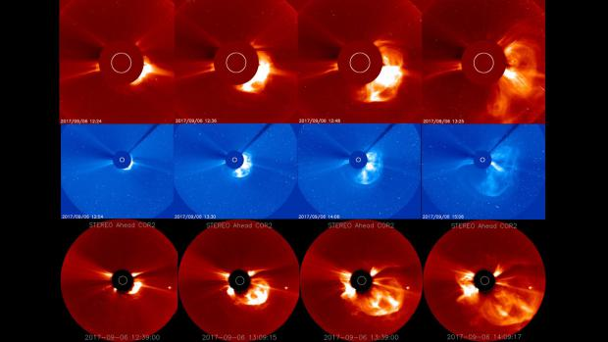
Coronal mass ejections (CME) shown leaving the Sun’s surface as seen from the solar pole.
4. So how powerful can CMEs become? Or, do you honestly want to know?
A. The largest predicted CME if 100% reached the Earth is about 10³⁸ ergs of energy.
B. A typical flare emits 10²⁹ ergs and the Carrington event is estimated to be 10³⁴ ergs.
C. Super-flares measured on other stars are 10³³ to 10³⁸ ergs.
D. The rotational energy of the Earth's crust and mantle above the liquid core is 2.2 x 10²⁹ ergs.
E. The power of the largest predicted CME striking and shrinking the ionosphere of Earth provides ample energy to jerk or rotate a magnetized mantle about the core, and for charged particles or plasma in the shrunken ionosphere to sustain stickmen (plasma in the glow mode) that travel between the lowered atmosphere and elevated plateaus and excavate the surface to form mesas, buttes, pinnacles, and redeposit stony layered sediments in many regions.
Which of the above data or predictions is neither accepted nor considered by consensus science?
ANSWERS: 1. D; 2. B; 3. C; 4. E.
Presented by Doug Ettinger, amateur astrophysicist (dougettinger@verizon.net)

Astrophysics Quiz No. 8 - Does Planet X Exist and Can It Be Located?
NASA has searched for 40 to more years with its most modern space telescopes to within several light years distance from our Sun for this allusive Planet X or star that researchers have named Nemesis.
1. Why do astrophysicists think Planet X or Nemesis exists?
A. Twelve mass extinctions have occurred over a very rough period of 26 million years during the last 250 million years.
B. Exo-solar stars are known to have planets in unusual orbits.
C. Exo-solar yellow dwarf stars like our Sun have other orbiting smaller, dimmer red or brown dwarf stars.
D. The enigma prevails that a rogue planet of an unknown source collided with the Earth to form the Moon.
E. Another mystery is a missing planet, and its impactor might have caused the Main Belt of asteroids. This proposed event is labeled the ‘disruption theory’.
F. Ancient myths and legends provide stories about a second Sun that appeared periodically in humankind’s recorded past.
G. A postulated band of comets, called the Oort Cloud, exists at 2 light-years distance, that is disturbed by a periodic passing star.
What above item does not apply due to its abandonment for other accepted reasons?
2. What detection method by NASA has not been used for this intensive search?
A. Normal land-based telescopes.
B. The Infrared Astronomical Satellite (IRAS) was used in the 1980s.
C. Applying ‘proper star motion’ and parallax with computerized programs to select candidates.
D. Optical interferometers using a large array of telescopes on Earth.
E. Combining visible light observations and infrared heat measured by the Wide-field Infrared Survey Explorer (WISE) spacecraft.
F. Photometry that compares the object’s apparent brightness magnitude with known absolute brightness.
G. Infrared tracking surveys combined with radar rebounding signals to estimate distance.
3. If our suspected Nemesis star is a brown dwarf, what are the issues for detection difficulties? Which stated issue is in error or does not apply.
A. Extreme dimness still allows photometry as a practical method for detection.
B. The outer infrared signature may be below the detectable limit of 150 Kelvin for a brown dwarf star due to its dusty corona that can shield heat. Suspected candidates can be confused with Kuiper Belt objects. For comparison, Jupiter’s surface temperature range is 165 K to 112 K.
C. Proper star motion may be made difficult due to an extremely elongated orbit around the Sun.
D. Photometry is not applicable because the brightness scales for brown dwarfs are unknown or inconsistent.
E. Electromagnetic signatures for X-ray detection may be shielded by surrounding disks of gases and dust.
F. By discounting brown dwarfs just outside the Kuiper Belt region can cause NASA to label certain data as anomalous, mysterious, and shelved for later analysis.
4. The search for Planet X was abandoned by NASA in 2014 but was later reactivated due to what reason?
A. Certain extremely elongated orbits of comets and asteroids aroused suspicions.
B. New study of data revealed missed celestial bodies in previous studies.
C. Investigations for potentially hazardous near-Earth objects (NEOs) required the continued activation of the WISE telescope.
D. Some recently discovered Kuiper Belt Objects (KBOs) such as Sedna have extremely large-period, elongated orbits suggesting it was perturbed by an unknown planet.

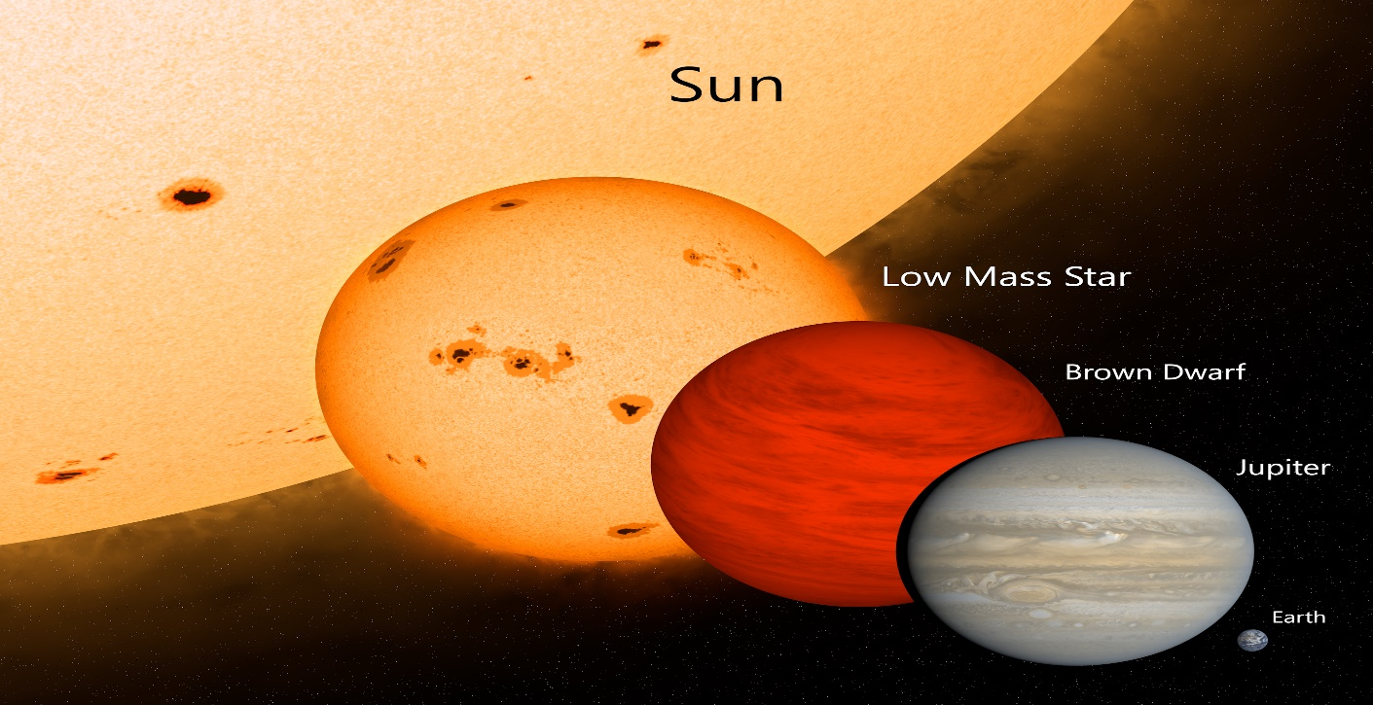
Relative scale sizes of celestial bodies that emit both radiant light or heat (infrared) or both.
Presented by Doug Ettinger, amateur astrophysicist (dougettinger@verizon.net)
ANSWERS: 1. E; 2. A; 3. A; 4. C.

Astrophysics Quiz No. 9: What do you know about extraterrestrials and UFOs?
Interest has been resurgent in 2022 about UFOs by various governmental agencies. Recent claims have surfaced that UFOs and extraterrestrial beings do exist.
1. Which claim is entirely ruled out about their source?
2. What origins are possibilities except are not within the realm of present known science for traveling the known distances?
A. From another planet in our solar system.
B. From a previous civilization on Earth.
C. From another star system, our closest is 4 light-years away.
D. Inside the hollow Moon.
E. From another galaxy.
F. From a possible brown dwarf with planets not detected yet that orbits our Sun.
3. Which type of designated ‘encounter’ is used for the direct interaction between humans and extraterrestrials?
A. Encounter of the first kind.
B. Encounter of the second kind.
C. Encounter of the third kind.
D. Encounter of the fourth kind.
E. Encounter of the fifth kind.
4. Have extraterrestrial beings ever been recovered from spacecraft wreckage and photographed?
A. Yes.
B. No.
C. Photos are revealed but not confirmed.
5. Why are most UFOs never considered to be manned by humanoid creatures?
A. Their energy emission is too intense.
B. Witnessed acceleration and deacceleration maneuvers are too sudden.
C. Their speeds are much faster than any known aircraft.
6. Have UFOs ever taken control of the military’s nuclear missile sites according to the latest compendiums?
A. Yes
B. No
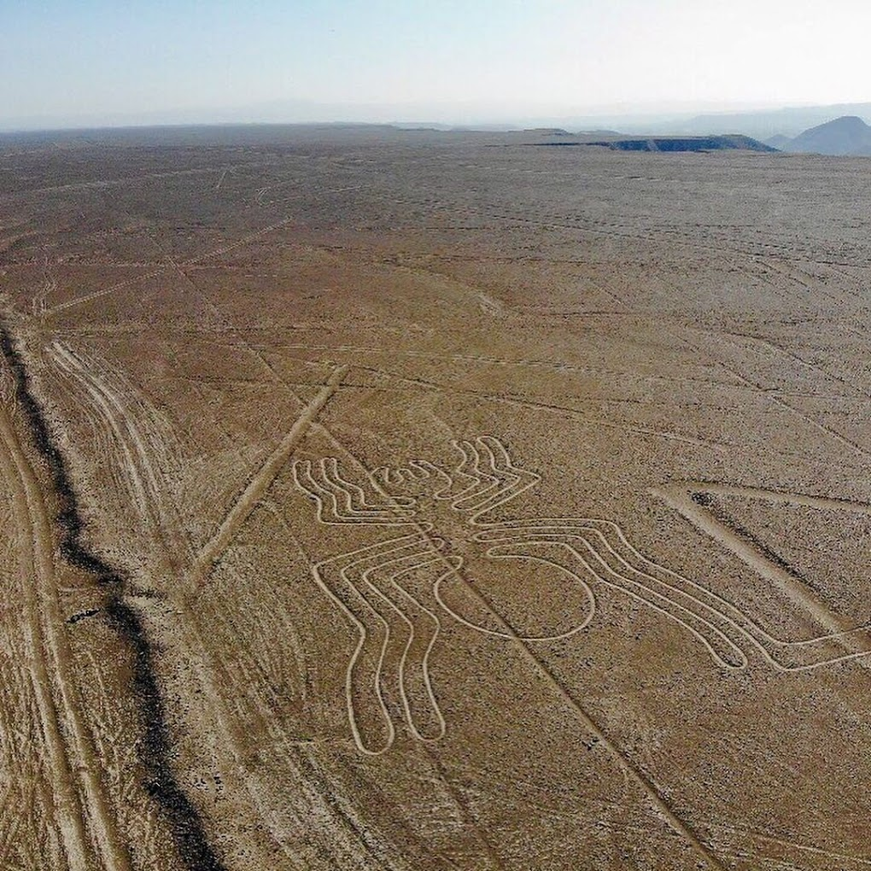
The ancient Nazca lines of Peru called geoglyphs can only be understood from aerial views. Were the primitive indigenous people awaiting the return of ancient astronauts?
7. What author made famous the real possibility that highly technical extraterrestrials visited our planet by his exposing anomalous ancient sites which could not be explained by archaeologists?
A. Carl Sagan
B. Issac Asimov
C. Erich von Daniken
D. Zecharia Sitchin
Presented by Doug Ettinger, amateur astrophysicist (dougettinger@verizon.net)
ANSWERS: 1. D; 2. C&E; 3. C; 4. C; 5. B; 6. A; 7. C.

Astrophysics Quiz No. 10: NASA’s Problems with the Earth-Moon System
NASA was hoping to resolve how the Earth-Moon system developed with the Apollo Missions and space probes to the Moon. But many lingering questions have not yet been answered. Do you have any ideas about how the Moon and Earth might have formed together in the same orbit?
- What is the chief reason against a typical capture mode where one body passes closely to the other for the Moon and Earth?
A. There is never enough time for gravity to pull a smaller body into any orbit around a larger body as is proven by calculus.
B. Not enough surrounding dust and gas is available to slow down the passing body.
C. Their comparable differences in composition and density are too similar.
D. The present distance between these passing bodies is too far.
- What is wrong with the nebular hypothesis that claims rings of dust and planetesimals coalesce to form a smaller orbiting body for the Earth/Moon system?
A. Their comparable difference in the mass ratio is 100 to 1000 times larger for the Earth to Moon than for the ratio of outer planets to their major moons.
B. The radius ratio of the Earth to Moon is a factor of 10 or larger than that of the outer planets to their major moons.
C. For consistency of formation inside the nebular dust cloud, Venus and Mars should have one or more major moons, too.
D. Only item C above.
E. The above items A, B, and C.
- Why does not the binary model work where one body is ejected from the other?
A. The energy required to launch the Moon would either destroy Earth and/or create an impossible large spin to achieve the Moon’s present angular momentum.
B. No known mechanism is yet imagined launching a moon from a parent planet.
C. The Moon is too large and too far away to achieve a possible binary model that may have been similarly utilized by the outer planets.
D. Only item B.
E. The above items A, B, and C.
- The current accepted process is the ‘Giant Impact Hypothesis’ where a rogue body glances off the Earth to re-coalesce and form the orbiting Moon. Which reason(s) refute this hypothesis?
A. Computer programming simulates most of this idea.
B. The Earth would spin too fast to sufficiently reduce the velocity of a glancing body into an orbit around Earth.
C. Neither the Moon’s orbital plane matches the ecliptic plane nor the Earth’s equatorial plane proving little correlation in their formation together.
D. The Moon’s rocks have few hydrated characteristics which should not be expected from hitting a wet Earth.
E. Only items B, C, and D.
F. All the items A, B, C, and D.

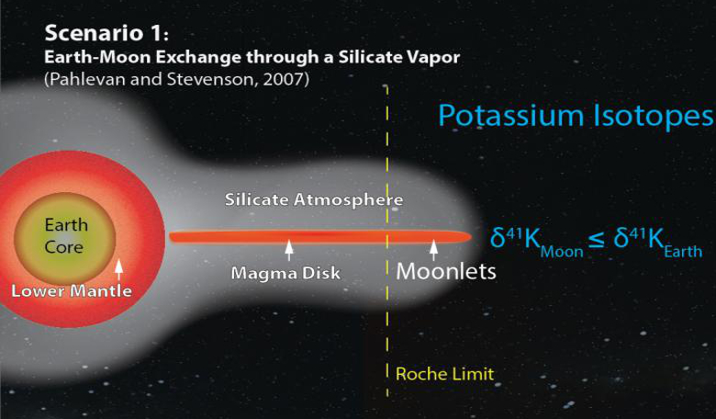
One of the numerous evolving ideas about the Giant Impact hypothesis comes from academia.

- An alternative process currently considered by NASA is a direct hit in which most of Earth’s mantle and the rogue impactor vaporize. The material above the Roche Limit coalesces to form the Moon and the material below the Roche Limit falls back to Earth.
Choose the known issues listed below that refute this alternative hypothesis.
A. Such a process would lose the lighter volatiles such as water and nitrogen into space.
B. This imagined process cannot create the necessary angular momentum to make the forming Moon orbit.
C. Both the Moon and Earth have some identical chemical isotopes which require more mixing than is the anticipated time for the vaporized materials to separate and reform the Earth’s mantle and coalesce into the Moon above the Roche Limit.
D 1. – A and C only; D 2. – A, B, and C; D 3. – B only.
- What reasonable process remains for the Earth and Moon to share the same orbit?
A. The binary model; B. The normal capture model; C. The collision model;
D. A possible capture model that can provide enough time; E. The LaGrange model where two distinct bodies formed in the same orbit; F. The nebular model with a coalescing surrounding ring.
Presented by Doug Ettinger, amateur astrophysicist (dougettinger@verizon.net)
ANSWERS: 1. A; 2. E; 3. E; 4. E; 5. D2; 6. D or E

Astrophysics Quiz No. 11A: The Oldest of the Old
What are the age of the solar system and its parts, and how is this information determined?
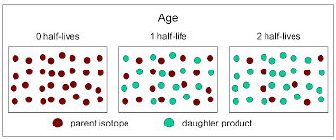
1. What method of dating is used to determine the age of the solar system?
A. Radiocarbon dating
B. Potassium-Argon (K-Ar) nuclide dating.
C. Cosmogenic nuclides decay by cosmic rays.
D. Radiometric dating using the proportions of 2 different isotopes in a sample.
E. Relative dating based on the ordered sequence of events.
2. Mineral isotopic decay over time allows for the measurement of absolute time due to:
A. The rate of decay of isotopes is generally considered to be constant.
B. The half-life of certain radioactive minerals can be measured and computed
where the rate of one-half of the parent isotope decays into a daughter isotope.
C. The half-life decay of numerous minerals is measurable for billions of years.
D. All the above items.
3. Ice-core analysis in Greenland and Antarctica allows scientists to reconstruct:
A. The ages of meteorites that fell on the ice caps over large periods of time.
B. The Quaternary environment of Earth.
C. The age of the Earth.
4. Why is the age of the Earth difficult to measure by dating the oldest rock?
A. Because erosion and biological changes erase the oldest rock.
B. Because of the Rock Cycle that constantly changes rock phases.
5. Why is the age of the Moon difficult to measure by dating the oldest rock on the Moon’s surface?
A. Because a thick regolith powder covers the virgin bedrock.
B. Because the Moon has no atmosphere to burn up falling space debris.
C. Because the rock record has been displaced with a jumble of meteorite strikes of
different non-lunar rocks.
D. Only items B and C.
6. The latest consensus ages are given correctly except for two. Which two?
A. The Sun: 4.60 billion years (by) preceding all the planets.
B. The solar system with its planets: 4.57 (by) based on the oldest meteorites.
C. The Moon: 4.42 (by) based on the solidification model of its magma ocean.
D. The Moon: 4.50 (by) based on Apollo rocks returned to Earth
E. The oldest planet: Mercury due to its closeness to the Sun.
F. Oldest bedrock on Earth: 4.28 to 3.80 (by).
G. The oldest meteorite recently found on Earth is igneous rock: 4.56 (by).
H. The oldest internal rock on Earth is considered part of the metallic core determined
by modeling: 4.57 (by).
Refer to the next Quiz 11B to examine the inductive reasoning to achieve relative dating by using the believed absolute radiometric ages of the solar system.
Presented by Doug Ettinger, amateur astrophysicist (dougettinger@verizon.net)
ANSWERS: 1. D; 2. D; 3. B; 4. B.; 5. D; 6. E & H.

Astrophysics Quiz 11B: Let’s examine the logic of radiometric ages.
Radiometric ages provide the best absolute ages for the solar system. If inductive reasoning is then applied, the relative ages or sequence of major events can then be determined. Remember that errors in dating can easily be plus or minus 50 to 100 million years or more according to scientists. Also, many creationists in the science fields question radiometric dating as being reliable.
1. The birth of the solar system is 4.60 to 4.56 billion years based on the oldest meteorites. The age of the oldest liquid water which is based on carbonates found on the oldest meteorites has to be older than 4.56 (by) or 4,560,000,000 years.
2. The oldest moon rocks are 4.50 (by); the mares on the Moon are 4.42 (by) based on solidification models of its past magma ocean.
3. The oldest minerals (Ziron crystals) on Earth are 4.30 (by) with the oldest bedrock on Earth varying from 4.28 to 3.80 (by). The oldest internal rock on Earth considered part of the metallic core determined by calculations and modeling is 4.2 (by).
4. The Moon from radiometric ages and modeling is older than Earth by at least 200 million years. The Moon’s surface could have solidified first without any atmosphere and being smaller, but 200 million years is too long of a span for a reasonble difference in their surface solidifications.
5. The oldest liquid water has to come from a planet near the young solar system’s snowline somewhere beyond Mars because the proto-sun went through the T-Tauri phase starting about 4.52 (by) that boiled volatiles off the closest inner planets. That watery planet has to be Earth because all the other explored planets either lack liquid water or have frozen volatiles including only minor remnants of water ice. NASA continues to search for elusive water or its past existence in other locations within the inner solar system besides Earth.
6. If a rogue planet struck Earth to form the Moon at one AU as is proposed by the consensus Giant Impact hypothesis, almost all water on both planets would have boiled away. Hydrated minerals would have survived, but liquid water needs to come from elsewhere after this hypothesized impact event and after the solidification of the Moon’s surface.
7. Earth’s age of rocks is younger than the Moon’s rocks. According to the solar system timeline, if the planets including the Moon were relatively created at the same time, why is the Earth significantly younger? The smaller Moon would have solidified first making it older instead of younger. Also, the period between their surface solidifications is too long to make reasonable sense.
8. Dating of the Late Heavy Bombardment (LHB) is anywhere from 4.0 to 3.9 (by) when the inner planets and the Moon were bombarded mysteriously by asteroids as given by crater counting methods; the nebular disk should have cleared away after 600 million years which is why the bombardment is called ‘late’. Could the LHB be caused by a major collision of Earth when orbiting between the orbits of Mars and Jupiter? Logically, after asteroid strikes due to LHB collisional debris diminished on Earth and after the surface re-solidified, primitive life began around 3.8 (by).
9. One more important dating span must be included. The Moon’s mares remained molten after the LHB for about 900 million years until 3.0 billion years ago. Continuous strikes of asteroids on the Moon, caused by this proposed planetary collision, that did not fall back to Earth kept these mares molten.
Armed now with these facts, let's try to apply some more logic. You tell me which logic is in error. Let's pretend that you are a NASA scientist or a master of logic. Please contact me with your ideas. I will enjoy hearing from you.
A. The only inner planet or body with significant water is Earth, so it has to be the missing planet of the ‘disruption theory’ that originally orbited near the snowline beyond Mars.
B. An impactor displaced Earth sunward leaving behind collisional debris of the Main Belt asteroids that reveal hydrated minerals and igneous-type rock that could only come from a planet with an already formed crust, CO2 atmosphere, and enough atmospheric pressure to condense water on the surface. Much of the primitive Earth’s water and additional water from the impactor had to be retained on its trajectory toward its current orbit of one AU.
C. Earth found a new orbit closer to the now cooler mature Sun while bringing some of its collisional debris; the engorged Earth with its added volatiles began sharing the same orbit with an existing terrestrial planet, the Moon.
D. The Earth and Moon never collided but exchanged gravitational energy to explain their distance from each other, relative size differences, different orbital planes, and their mysterious angular momentum arrangement.
E. The collisional debris brought by Earth either fell back to the surface or was swept up by the Moon for the next 900 million years causing the long-lived molten mares.
F. Earth’s frozen impactor not only created the asteroid belt but also the Late Heavy Bombardment (LHB) whose dating aligns with the oldest age of Earth’s bedrock that re-solidified after impact around 3.9 to 3.8 billion years ago.
G. Geologists also now have good reason to suspect that this major impactor created a super-caldera which became the first supercontinent or partially globally raised surface. The consistent difference in the oceanic and continental crusts, active volcanism, and geological hot spots are correlated causes that are still with us. These major features are not found elsewhere in the solar system.
H. The resolution of the Apollo mission revealing identical mineral isotopes for both the Moon and Earth rocks is now given. Earth’s collisional debris was brought to the Moon during their orbital marriage. Also, the unusually large iron core of the Moon is answered because it never came from a glancing collision with Earth but already existed in its pristine state as an original terrestrial planet.

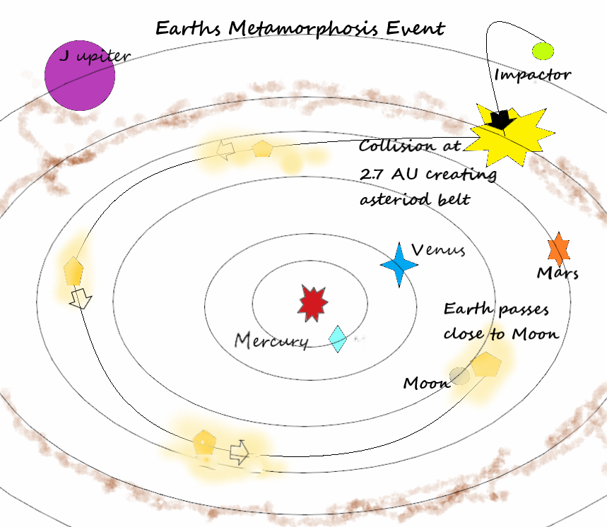
Diagram of Earth’s major collision showing its orbital displacement sunward and matching orbits with the Moon as their gravitational energy was exchanged after each pass of Earth.
Presented by Doug Ettinger, amateur astrophysicist (dougettinger@verizon.net)
ANSWERS: Hopefully, already has been given, but please tell me if you differ. In this quiz, you are allowed to differ from NASA’s paradigms. Thank you for your interest.

Astrophysics Quiz No. 12: Refuting the Nebular Hypothesis Paradigm
Consensus science relies heavily on the nebular hypothesis to explain the formation of stars and our solar system but is this process even possible? An anomalous gravitational attraction and possibly shock waves from supernova explosions supposedly cause the gathering of interstellar clouds of dust and gases that then create a swirling disk spiraling inward toward a gravitational anomaly called a protostar. Concentric rings of dust coalesce to form the orbiting planets.
1. How do the Earth/Moon system and Uranus’ planetary system disprove this hypothesis?
A. Our Moon is too large compared with Earth and too far away from its parent.
B. Our Moon never completely orbits Earth but weaves about Earth always being concave toward the Sun proving its main gravitational attraction comes from the Sun.
C. Uranus’ spin axis is parallel to its orbital plane resembling a rolling wheel.
D. The major moons of Uranus have orbital planes that are perpendicular to the ecliptic plane and mostly align with Uranus’ equator.
E. Uranus was likely struck by another celestial body to turn it on its side.
F. All the above items.
G. Only items A, B, C, and D.

2. How does the distribution of the solar system’s angular momentum refute the hypothesis?
A. As most of the nebular disk swirling material moves inward to form the protostar, most of the angular momentum of the system should transfer to the star but does not.
B. The Sun spins relatively slowly leaving most of the angular momentum to unexplainably reside with the fast-orbiting planets.
C. Both items A and B.

3. How do the spin axes of the planets, the planet’s orbital planes, and the orbiting planes of their major moons affect the nebular hypothesis?
A. None of the above characteristics align very well with the ecliptic plane expected to be the postulated level plane of the original nebular disk and developing planets and moons.
B. Most of the above characteristics align well enough to characterize a nebular disk about the Sun and smaller dusty disks about the major planets to create their moons.
C. Collisions and perturbations possibly address with high probability the misalignments to the ecliptic plane if these anomalous disturbances can be explained by bodies that then either crashed into the Sun or were ejected from the solar system or are still mysteriously orbiting the Sun.
D. Both A and C leave doubts about the nebular hypothesis.
4. Binary stars are two stars in proximity by which one revolves around the other or both revolve around a common center. An estimated 85% of stars are either binary or higher multiple systems. How do these facts refute the nebular hypothesis?
A. The nebular hypothesis addresses Jupiter as a failed star and in the same way, explains the evolution of binary stars.
B. Anomalous binary systems have much difficulty supporting the singular nebular disk idea. Some of these anomalies are extremely fast orbiting stars, very close orbiting stars, stars orbiting about a common center, and very large stars having multiple brown or red dwarf stars at varying orbital distances. Consistent computer simulations cannot possibly match all these scenarios to support the nebular theory.

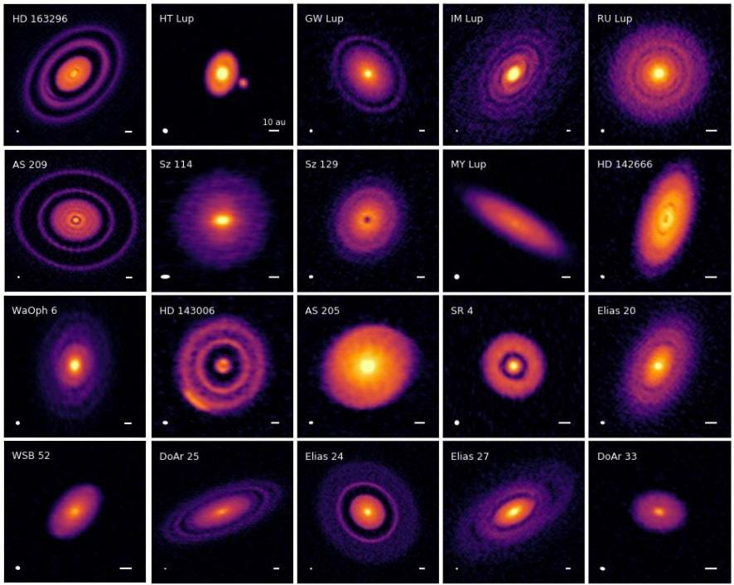
Images of protostars’ nebular clouds or rings supposedly forming orbiting planets. The question remains for me as to whether the star came first and then emitted the nebular cloud or rings. My question is like asking what came first. The chicken or the egg.
5. The most important challenge for the nebular hypothesis is how a gravitational attractor is started and is strong enough to suck in dust and gases from a surrounding interstellar giant molecular cloud (GMC). What facts about the protostars and GMCs are incorrect?
A. The density of a typical GMC is very vacuous at 3.32 x 10⁻⁸ kg/km³ and the mass of an average star like the Sun is 1.99 x 10³⁰ kilograms.
B. The minimum required GMC volume to form the Sun is equal to the spherical radius of 160,000 AU as computed by using the Sun’s mass and dividing by the average density of a GMC.
C. The gravity field of our Sun is almost non-existent at two light-years or 126,000 AU, the radial distance of the supposedly existing Oort cloud of comets.
D. The Sun requires at least a surrounding GMC of radius 160,000 AU to acquire its mass assuming no other close-forming stars are stealing mass from the same GMC.
E. The Sun’s protostar cannot possibly have enough gravity effect at 160,000 AU for any time during its formation to attract even a small fraction of its known mass over the given time allotted for the universe.
F. Protostars are predicted to lose 1/3 to 2/3s mass of their nebular disk before becoming a main sequence star which further disproves enough mass for a new protostar.
G. None of the above items are incorrect.
H. Item E and F are incorrect.

Presented by Doug Ettinger, amateur astrophysicist (dougettinger@verizon.net)
AMSWERS: 1. G; 2. C; 3. D; 4. B; 5. G.

Astrophysics Quiz No. 13: Replacing the Nebular Hypothesis Paradigm
If the nebular hypothesis of the gravitational collapse of interstellar material is disproven, then what can replace it? Let’s take another look at the binary model where a body ejects from a much larger body. Certainly, this process is no stranger to us. Life uses the binary model all the time from the simplest to the most complicated organisms to reproduce. Take a walk on the wild side and consider the binary model and stop the paradigm paralysis!
1. What observations support the binary model for creating planets and moons?
A. The parent body radius is typically 10 to 50 times larger than the orbiting body; the Sun has 1000 times more mass than the largest planet, Jupiter; and Jupiter has about 12,000 times more mass than the largest moon demonstrating the large differences in scale. The parent body could easily birth the smaller bodies apart from the Earth and Moon.
B. The major moons typically have 3 to 20 times more orbital distance than the radius of the parent body and orbit closely within the equatorial plane of the parent demonstrating expulsion from the spinning planet at low latitudes extolling centripetal forces, the Roche Limit, and limiting escape velocities at work.
C. The sizes, compositions, and densities of the moons vary similarly to the planets which are like a soup boiling over and expelling different vegetables for both the Sun and the planets.
D. The secondary bodies have stable, individual, almost concentric orbits which imply a plausible electromagnetic (EM) cause as opposed to a strictly gravitational reason.
E. All the above items.
F. Only items A and B.
2. What evidence is available to show where the planets’ higher volatiles came from if the Sun as claimed is only in the business of burning hydrogen to produce hydrogen isotopes and helium? Please identify only bona fide, accepted science and eliminate the speculation which could lead eventually to another possible hypothesis.
A. In 1869 scientists studied the Sun’s corona and eventually detected 67 chemical elements in this outer perimeter using spectrometry.
B. In 1939 it was discovered that spectroscopic readings of the corona revealed iron stripped of numerous valence electrons revealing the unexpected corona temperature of 2 to 3 million degrees Kelvin with a surprising temperature of only 6500 to 4000 degrees K in the lower photosphere.
C. Possibly stars as they form in a compressed Z-pinch from incoming polar electrical currents arriving from the center of the galaxy, synthesized a spectrum of higher elements.
D. The analyzed high temperatures of the corona create high energy plasma in which many valence electrons are stripped from different atoms and move freely; hence, speculation occurs that the heavier, positively charged, ionized atoms fall through the photosphere into the negatively charged interior revealed by dark sunspots that are curiously astronomers’ eyes into the Sun’s coolest region. However, NASA claims surprisingly with calculations that the core of the Sun is 27 million degrees F. which is required for their theorized hydrogen fusion process.
E. The equilibrium of overall charge density becomes increasingly unbalanced in the center of the Sun to the point where large lumps of these attracted ionized protons of varying elements are belched near the Sun’s equator overcoming gravity and EM forces, and then expelled onto the ecliptic plane pulling along the necessary valence electrons and lighter elements such as hydrogen and helium to create planets. In the case of other stars, smaller sister stars may be created and launched similarly.
F. These ejected proto-planetary lumps have not attained charge parity or equilibrium after reaching their final orbital positions and expel smaller lumps into moon orbits; the cooler interior of the proto-outer-planets gives enough time for the common molecules of water, ammonia, nitrous oxides, and carbon dioxide to form which then are expelled along with heavier elements such as iron and sulfur via these moons that then differentiate into layers before freezing in the colder regions far from the Sun.
G. The terrestrial, rocky planets that began orbiting closer to the warm protostar have their envelopes of hydrogen, helium, and other lighter volatiles boiled away.
H. Only A, B, D, and G are accepted by consensus science.
I . All items are accepted science introduced by a theory called the Electric Universe.

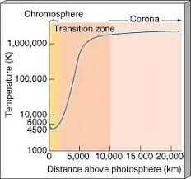
3. What listed curiosities are not known to be completely true but perhaps should be considered?
A. The Sun is equivalent to 333,000 Earth masses (M_{E}) and is also estimated to have its mass composed of 0.01 % metals that do not include hydrogen and helium; that 0.01 % is equivalent to 33 M_{E} which is a substantial part of Jupiter’s mass at 318 M_{E}, and the total mass of 450 M_{E} for all the planets. Could the young Sun possibly have kept generating these metals in its corona and then dispersed them as planets?
B. The maximum temperature to fuse hydrogen into helium is 100 million degrees Kelvin; the highest measured temperature of 2 to 3 million K. for achieving plasma in the Sun is in the corona, although, NASA claims by calculations that the Sun’s core is 15 million degrees K.
C. A typical star has enough time, temperature, and pressure (via a Z-pinch, a phenomenon in plasma physics) to produce most of the other major elements as is witnessed in its coronal perimeter without applying the theory of stellar nucleosynthesis involving fusion inside the core of a star.
D. Plasma laboratories have simulated small-scale spiral galaxies that expel high energy current from a central point into a donut shape forming Z-pinches; these Z-pinches potentially may simulate stars that form in the galaxy disk and are possibly fed electrical energy into their poles via the dark mode of plasma or Birkland currents coming from the galaxy’s center. Shedding charged particles in the solar winds and CMEs by stars in varying amounts is a possible mechanism for maintaining charge equilibrium.
E. In fusion power research, the Z-pinch is a type of plasma confinement system that uses an electric current in the plasma to generate a magnetic field that compresses it at extremely high temperatures and synthesizes elements. With enough high energy arcing, not yet achieved, possibly a complete smattering of the higher metals below the iron valley in the periodic table could be created to eliminate or radically modify the current stellar nucleosynthesis theory.
F. Items C, D, and E.
G. Only item C.
This quiz is very technical and may require some guessing. Have fun pondering and guessing. The answers, although controversial have partially attained consensus acceptance.

Temp. profile of Sun’s corona.

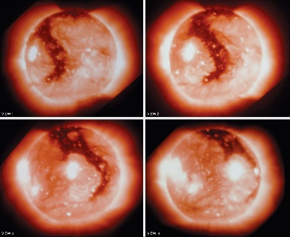
Presented by Doug Ettinger, amateur astrophysicist (dougettinger@verizon.net)
ANSWERS: 1. E; 2. H; 3. G.
.
Corona with flares and holes as Sun rotates.

If you do not agree with some of the answers, please contact me for some interesting discussion.

