Response to a Casual, But Important Peer Review of this Paper,
A Brief History of Mankind’s Chaotic Past
June 2017, Version D

Table of Contents
Response to a Casual, But Important Peer Review of this Paper, A Brief History of Mankind’s Chaotic Past June 2017, Version C 1
1. Introduction 1
2. Re-examining the Major Disturbances on Earth for Each Return of Nemesis 2
3. Why Can the Nemesis Brown Dwarf Star Not Be Found? 19
4. Is the Nemesis Hypothesis Realistic in Terms of Orbital Mechanics? 30
5. The Stability of a Binary Star System Such as the Sun and Nemesis 39
6. Conclusions about Nemesis 40

Introduction
In May of 2017, I was honored and privileged to receive a brief, but very important peer review of one of my papers. A person connected with various NASA programs and trained in astrophysics provided concise and sincere criticism of three main points made by my paper. The first point is my plotting of the data of historical events, both mankind and natural, of the postulated cyclic events of the returning Nemesis star to the inner solar system every 3600 years. The paper uses as the main datum point, the end of the well-defined Younger Dryas geological period which is 11,500 years BP. The paper then continues to subtract or add 3600 years from that point in time to determine other visitations of the Nemesis star and look for disturbances on Earth at those times. The major fault revealed by the peer review was that no stated research used a continuous plot of major Earth events between those points in time. Per the criticism, it is an easy matter to look for any event occurring during certain peak times and ignore all others; the logic is flawed and no real conclusive evidence is gained. Yes, I agree that a more continuous plot of data is required.
A second point made by the peer review is that NASA has made a thorough search of the heavens for a Nemesis-type star or planet, in particular a brown dwarf star and none was found. The WISE space probe mission is claimed to detect surface temperatures as low as 150 K. For this peer reviewer, the NASA survey is very conclusive. The survey reports that the WISE data negated any Neptune-sized object from existing less than 700 AU away, any Saturn-sized object existing between 2 light years away and out to ten thousand AU, and any Jupiter-sized object out to one light year or 63,000 AU assuming their surface temperature is above the detectable limit of about 150 K. What is needed for this paper is more emphasis on the paradigms and limitations of the NASA surveys.
The third point of criticism is key to the whole idea of an orbiting Nemesis star or planet. Does known orbital mechanics allow such a configuration? The main doubt for the reviewer was the stability of these two systems lasting several 10s of thousands or millions of years. This stability issue, of course, is one of my biggest doubts, too. Some simple mistakes were also discovered in my equations for determining the basic parameters of the orbit for the postulated brown dwarf star. The reviewer’s analysis helped me re-think Nemesis’s orbital trajectory by considering a higher ratio for the major and minor axes of the elliptical path. He hinted that I needed to calculate the latus rectum of the trajectory which further excited me. Perhaps, the latus rectum of the trajectory could be used as a datum point since the Nemesis system is assumed to pass through the vicinity of the Main Belt of asteroids, about 3 AU from the Sun, and disturb them for each crossing. Then, I realized that the trajectory of Nemesis inside the solar system could go as far as Neptune making that point the periapsis of its elliptical path instead of the average orbital diameter of the Main Belt of asteroids. If the elliptical trajectory is very inclined such as 25 to 30 degrees or even more to the average elliptical plane of the Sun’s planets, then interaction of the Nemesis system with all the Sun’s planets has less chance making the hypothesis more acceptable. This type of trajectory provides a better chance for more long-term stability of the two-star system. I need to go back to the drawing board, calculate, and sketch better possible orbits.

Re-examining the Major Disturbances on Earth for Each Return of Nemesis
The predicted times for Nemesis’s visits to the inner solar system are the years before the present (BP): 18,700; 15,100; 11,500; 7900; 4300; and 700 (1300 AD). The next arrival is predicted for 4900 AD. So, any continuous kind of record going back 20,000 years or even 11,500 years ago is a bit scanty the farther back one goes. Checking the history of volcanoes from www.randomhistory.com reveals a random occurrence going back to 1600 BC. Going farther back reveals more random volcanoes to about 4000 years by using the Timeline of Human Prehistory. However, during the 8th millennium (7911 BC) seven massive volcanic eruptions occurred lowering the global temperature for several centuries as revealed by Greenland ice cores. Other major known, dated volcanoes occurred in the 7th millennium (6600 to 6100 BC): the 900 km² lava fields of Iceland, the Kurile volcano on Siberia’s Kamchatka Peninsula; and volcanic fields in central Washington State. The 6th millennium (5677 BC) had eruptions of Mount Etna in Sicily and Mount Mazama in Oregon creating Crater Lake, the largest eruption in the Cascades. These eruptions more than likely resulted from the continued settling of Earth’s geoid displacement during the Great Deluge Event of 11,500 years BP. However, the next predicted visit of Nemesis in 5900 BC could have caused some further gravitational and magnetic adjustments of the Earth’s crust at that time. One difficulty of dating ice cores is the lack of known volcanism to be used as markers that occurred any earlier than 8500 years BP.
The source, www.randomhistory.com, also lists major earthquakes and tsunamis. The oldest, super tsunamis are predicted to result from an asteroid that struck the Indian Ocean causing waves 600 ft. high; and the sudden tectonic plate movement that caused the tsunami in Crete and surrounding Mediterranean coasts in 1530 BC. Other tsunamis from the Timeline of Human Prehistory indicated a super tsunami, the Storegga slide in the Norwegian Sea in 6100 BC and another super tsunami in the Eastern Mediterranean thought to be caused by Mt. Etna’s eruption. This search for earthquakes and tsunamis gives a similar result of random occurrences and nothing documented or discovered earlier than about 4000 years except for the previously mentioned super tsunamis. The randomness of earthquakes and tsunamis is probably the result of small tectonic plate movements since 80% occur in the Pacific Ring of Fire. One of the reported major earthquakes occurring in the eastern Mediterranean around 1201 AD corresponds closely to the 1300 AD predicted visit of Nemesis. Major volcanoes occurring near this date are Mt. Vesuvius in Italy in 79 AD and Hatetepe in New Zealand in 180 AD. But there are no conclusions to be made about Nemesis’s visit in 1300 AD or any other visit during mankind’s prehistory by studying the data of volcanoes, earthquakes, and tsunamis. Also, no conclusions can be made about the history of hurricanes which only goes backward to 1900 as revealed by www.nhc.noaa.gov/outreach/history. So, what other historical data can be analyzed to search for some periodic cycle for the orbiting Nemesis?
Studying the rise and fall of interlocking civilizations and the beginnings of major cultural developments such as pottery, proto-writing, the Copper, Bronze, and Iron Ages may reveal when major disturbances on Earth caused the downfall or required the rise of replacement cultures and different techniques for surviving. Again, the Timeline of Human Prehistory and also the Timeline of Ancient History are consulted. Some of the earliest dated human developments are listed:
^ 200,000-180,000 years ago: Time of mitochondrial Eve & Y-chromosome Adam.
^ 195,000 years ago: Oldest homo sapiens fossils.
^ 70, 000 years ago: cave wall abstract art and personal adornments.
^ 64,000 years ago: bow and arrow following the spear.
^ 50,000 years ago: sewing needle
^ 42,000 years ago: Paleolithic flute and high-level maritime skills in East Timor
^ 40,000 years ago: figurines
^ 29,000 years ago: ovens
^ 28,000 years ago: twisted rope
^ 25,000 years ago: huts built of rock and mammoth bones
^ 20,000 years ago: harpoons, saws, oldest pottery
^ 15,000 years ago: domestication of the pig
^ 12,000 years ago: domestication of sheep and goats
^ 11,000 years ago: construction of ceremonial sites
^ 10,500 years ago: domestication of cattle
^ 10,000 to 9000 years ago: barley and wheat along with bread and beer begin
^ 7500 years ago: invention of wheel and proto-writing and copper smelting
^ 6000 years ago: domestication of horse and chicken with civilizations
developing around the Fertile Crescent of the Middle East
^ 5300 years ago: Bronze Age begins
^ 5200 years ago: writing was invented
What is revealed in this brief, abbreviated list is that humans were well-developed before antediluvian times. The Great Deluge event with all its utter destruction caused man to start almost all over again around 11,500 BP. However, as can be easily seen, his skills for both survival and a vibrant culture were already honed.
The radiocarbon dating for these discoveries in anthropology and archeology is questionable due to natural historians having a strict paradigm of human culture progressing forward from the stated Stone Age period called the Neolithic Revolution that supposedly occurred around 11,000 to 9000 years BP. Of course, mankind’s technological evolution is assumed to have started at that time because previous technologies and their required knowledge were obliterated during the Great Deluge. If so-called anomalies in the dating method occurred that led much farther back to 20,000 or 100,000 more years, historians would dismiss or even banish this information as being just errors in laboratory techniques of dating. No one can really know for certain at what stage man evolved prior to antediluvian times or prior to 11,000 years BP. Keep in mind, that many of these digs where artifacts of tools and art were found, are very distant and isolated from any ancient urbanization where education could be directly passed on. The implication is that advanced knowledge was well implanted worldwide for the majority of humans wherever they existed.
The challenge is still to find cycles for Nemesis’s crossings into the solar system. The Timeline of Human Prehistory shows man’s progress from 11,000 years BP to about 5,500 BP and covers the time from the Middle Paleolithic (Old Stone Age) to the beginnings of the Bronze Age. No periodicity of about 3600 years can be found in the listing of the ages of mankind’s settlements, cultural developments, and artifacts. However, the constant rate of development does not exist. After the Great Deluge, there was little chance for any possible easy communication or transportation of people; languages and cultures became disconnected and progressed at different rates with many distinctions. Suspicions and paranoia are created when any of the isolated cultures meet up thereby delaying progress in many regions.
The Timeline of Ancient World History is a collection of historical events that goes from the 10th millennium BC (12,000 years ago) to the 4th century AD. Starting with the 40th century BC the data becomes more populated for each century as time moves forward. This documented timeline goes from the beginning of recorded history to the Early Middle Ages and includes the Bronze and Iron Ages. The source https://www.eh-resources.org/timeline-middle-ages/ extends the analysis of timelines into the Middle Ages and the Early Modern Period. What is essentially revealed is a random continuum of beginnings and endings of civilizations, large migrations of people, droughts, animal and plant domestications, and technological/cultural developments. However, when one connects the tracking of changing climatic conditions with the various collapses of civilizations, cyclic periods do appear. These periods of climatic maladies pop out to grab your attention. Many recent studies have been made in these areas of historical climatic conditions because of the present concern for global warming and the unwanted, accelerated rise of sea levels. These studies consist of the “kiloyear events” that were assembled with the combination of global temperature changes from Gisp2 Ice Core Data of Central Greenland and other ice core data of mountain regions, sedimentary records, aridification records, methane concentration in the atmosphere, hemispheric cold snaps, sea level changes, and the collapse of various civilizations caused mainly by drought.
Another set of climatic fluctuations in the Holocene Epoch called the Bond events attempts to identify a 1500-year cycle. These events are mainly based on petrologic tracers of drift ice in the North Atlantic. Gerard C. Bond of Lamont-Doherty Earth Observatory at Columbia University tried in vain to establish such a cycle but lacks a clear climate signal where only certain peaks correspond with periods of cooling and other peaks are only coincident with the aridification of large regions. Mr. Bond failed to attach his cycle to some kind of solar cycle and lacked an adequate model for encompassing all the known climatic, atmospheric, and geological fluctuations. Bond’s postulated theory is currently claimed to be a statistical artifact with no cause or effect and has been rejected. The only Holocene Bond event that has a clear temperature signal in the Greenland ice cores is the 8.2 kiloyear event.
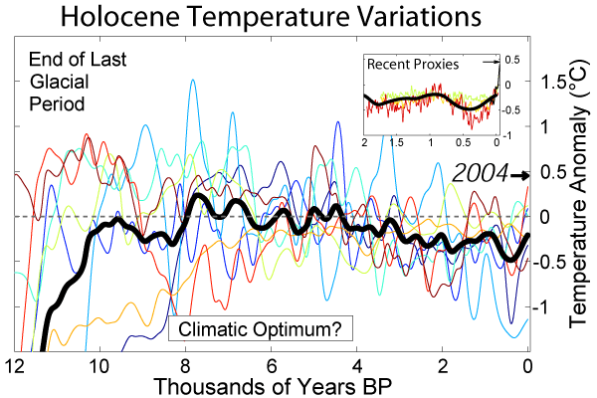
Figure 1: Gerard Bond unsuccessfully postulated a 1500-year cycle using ice core data going back 12,000 years ago.
This paper is also trying to identify a certain periodicity, but this time the cycle is an average of 3600 years span of time due to the orbiting Nemesis brown dwarf crossing through the solar system. However, the periodicity is more complicated because this model offers not only a mean period but also variability in its range of effects due to electrical/magnetic phenomena created by the two-star system. This model relies on the always-changing electrical charge of the two stars. As the brown dwarf with its magneto--sheath crosses the magneto-sheath of the Sun at least twice during one orbit, an exchange of electrical charge takes place in different amounts thus affecting the outpouring of solar wind for the Sun’s system to reach equilibrium. The solar wind fluctuations in turn affect the anodic or negatively charged planets of the Sun including Earth. Also, due to the Sun possibly increasing or decreasing its electrical charge the orbits of the planets have to make minor radial adjustments which have little to do with gravitational forces.
The fluctuating solar wind and minor changes in the orbital radius of the Earth both affect the weather and climate of Earth. Also, changing magnetic and gravitational influences will affect the geological stability of the Earth’s crust in different and random ways.
If the orbit of Nemesis is highly inclined to the ecliptic plane of the Sun’s planets it not only crosses the Sun’s magnetosheath twice in a postulated 400 + 50-year cycle to possibly exchange electrical charge but also crosses the ecliptic plane twice in the region of the Main Belt of asteroids situated about 2 to 3 AU from the Sun causing some major perturbations of various minor-sized celestial bodies. So, the hypothesis of this paper not only includes a 3600-year cycle, but a 400 + 50-year cycle within the larger cycle. The effects of each cycle are different due to varying exchanges of charge between the two stars; the varying exchanges of charge between the two stars and their planets due to fluctuating solar winds; and slight adjustments of planetary orbital radii that result in different inputs of radiant energy that are either increased or decreased.
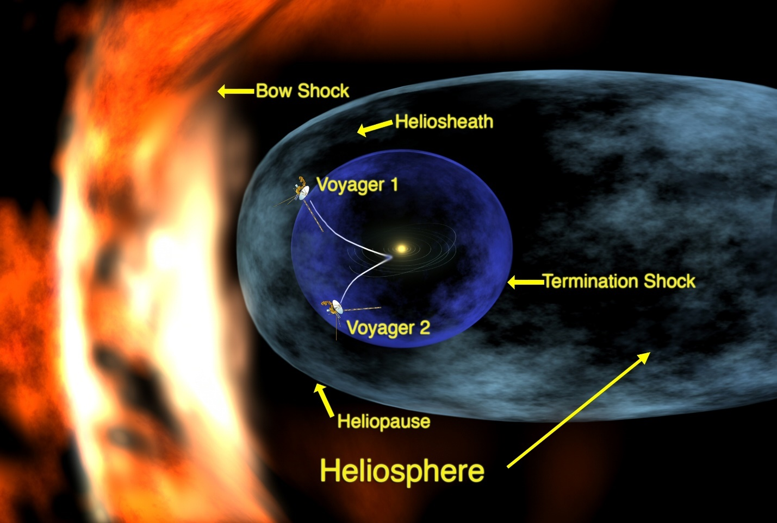
Figure 2: The Voyager space probe missions have proved the existence of the Sun’s heliosphere and heliosheath boundaries.
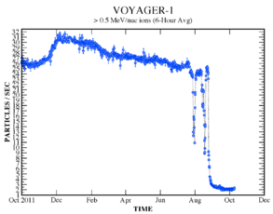
Figure 3: Voyager-1 Space Probe Data as it Approached the Heliosheath
This figure shows how the solar wind particles are captured by the Sun’s heliosheath which in turn provides a double-layer current for collecting external interstellar particles and the means for re-supplying the Sun’s energy at its poles. If the Nemesis star crosses this sheath of current, then power can be transferred in either direction depending on the requirements of the system’s charge equilibrium.
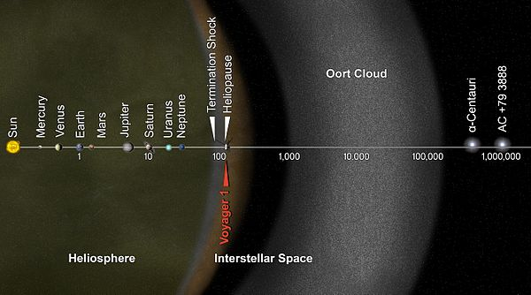
Figure 4: This figure indicates the rough location of the heliopause or heliosheath at 100 AU from the Sun which is over twice as far as Neptune, the farthest planet.

Henceforth, the Earth endures these cyclic changes in the solar system through changing weather, climate, and minor crustal adjustments. No pure cycle can be identified with any certain cause. The only chance of reckoning is to identify a possible mean cycle of 3600 + 100 years with a full range of effects that occur within this cycle once for a span of 400 + 50 years. The accuracy of these predictions is based on a reasonable exchange of charge between the two stars and between these stars and their planets, the perturbations of the orbits, the precession of orbits, and orbital radii adjustments. These predictions cannot be solely based on gravitational considerations which consensus scientific thinking does. The more powerful, still mysterious, electrical-magnetic forces between celestial bodies are what maintain stability. Now, let us look at how all these changes on an interstellar and planetary scale affect Earth by examining the following listed kiloyear events.
The best-defined climatic fluctuation is the 8.2 kiloyear (8200 years ago) event that followed the Great Deluge event of 11,500 years BP. There was a sudden dramatic cooling and drying on a hemispheric scale as shown by the Central Greenland ice core data. The temperature drop was not as severe as the Younger Dryas cold period, but more severe than the Little Ice Age. The duration was about 150 years. There was an emission reduction of 15% in atmospheric methane, and CO₂ was lower by about 25 ppm over 300 years. Drier conditions started in North Africa and persisted for a 300-year aridification and cooling period. As the atmosphere is cooled dryer conditions prevail because the water vapor is quickly condensed retarding the Earth’s water cycle of ceaseless evaporation and condensation. These drier conditions provided a natural force for Mesopotamian irrigation-type agriculture and surplus production to achieve the classes of people found in urban life. These pressures on human agrarian culture led to more evaporation, drying, and soil erosion. The 8.2 kiloyear cooling is attributed to the meltwater pulse that became permanent. The sudden rise in sea level is ironically, but supposedly caused by the melting and collapse of the Laurentide Ice Sheet and drainage of Lake Agassiz-Ojibway in Canada. The irony is how a cooling period could collapse the existing ice sheets and raise sea level; data from the Rhine-Meuse Delta indicates a rise of 6 to 13 feet. Similar sea level data shows similar rises in the Mississippi Delta, northwest Europe, and Asia. This sea level data may be confused with oceans still receding after the Great Deluge. The remaining ice sheets that were moved southward after crustal/mantle displacement, continued to melt due to their new warmer latitudes regardless of the overall global cooling. The story of the Laurentide Ice Sheet moving southward during the Great Deluge is a missing link for consensus science.
For this author, it is very suspicious that in 2003, the Office of Net Assessment (ONA) at the United States Department of Defense was commissioned to produce a study on the likely and potential effects of modern climate change. The study under ONA head Andrew Marshall modeled a possible climate change based on the 8.2 kiloyear event. Do “people in the know” want to keep as classified data any information being gathered about the Great Deluge and its lengthy aftermath? The academic community was not trusted to perform this ‘net’ assessment of mankind’s real genesis and revelation.
The conclusion for this paper is that the 8.2 kiloyear event meets the conditions for the next period of return for Nemesis predicted at 7900 BP. The effects of another star such as Nemesis crossing the helio-sheath of the Sun every 3600 ± 100 years seems very plausible. On its entry into the solar system, another span of 400 ± 50 years later is postulated for Nemesis’ crossing the helio-sheath once again before leaving the solar system. As the magneto-sheaths of the two stars cross each other, massive electron exchange can go in either direction for charge parity to be achieved. If the Sun loses electrons to the brown dwarf then the solar winds toward Earth are reduced; if the Sun gains electrons then the solar winds increase toward Earth. Other shorter-term effects are produced by the perturbations of various planetary orbits and the barycenter adjustments between the two stars. These shorter-term effects vary widely in severity depending on the orbital locations of the various planets for each other and the two stars. Hence, weather/climatic fluctuations, glaciation/cooling periods, and even geological disturbances on Earth will be affected, but not in any perfect periodicity or amplitude. The only real periodicity is the mean average of the 3600-year orbital period that uses the Great Deluge event of 11,000 years BP as one sharp and well-established datum point.
The 5.9 kiloyear event is the beginning of intense aridification events of the Holocene which started the desertification of the Sahara and much of Western Asia. Unlike the 8.2 kiloyear event, it did not have temperature markers in the ice core data or other markers such as methane and CO₂ fluctuations in the atmosphere. Unlike other major kiloyear events it was not followed by any significant recovery. Its effect has continued relentlessly to present times. In the preceding millennia before 3900 BC or 5900 years BP Neolithic humans introduced domesticated animals and agrarian culture that may have played a significant role in stripping vegetation that caused cascading effects of both drier weather and climate. This labeled 5.9 kiloyear event is not considered as marking the return of Nemesis; this event is merely the onset of serious aridification due to continued cooling and drying by natural weather forcing and humans destroying the environment on the Arabian Peninsula and in eastern Africa. The subsequent drier atmosphere led to further degradation farther westward into northern Africa.
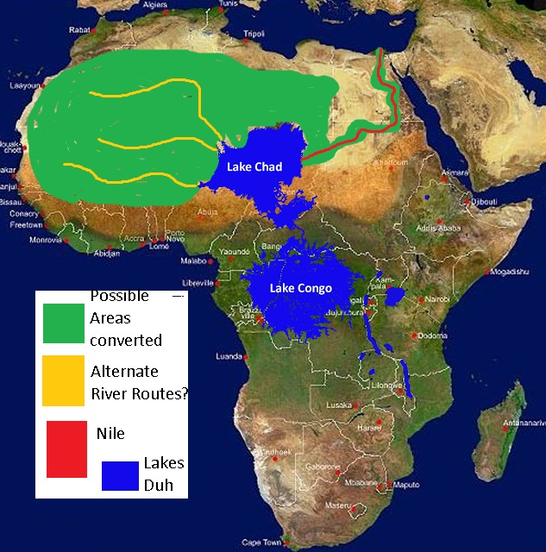
Figure 5: The Predicted “Wet Africa” before Major Aridification
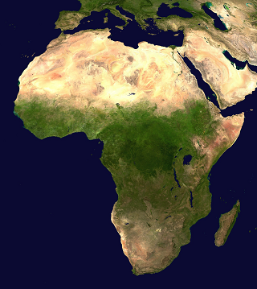
Figure 6: Satellite View of Africa Showing Present Aridification
The above figures show the difference between a ‘Wet Africa’ or the Neolithic sub-pluvial period of wet and rainy conditions in the Sahara about 7500 to 3000 years BC versus the dry Northern Africa and Eastern Asia of today shown by satellite photography.
The 4.2 kiloyear event was the most severe aridification of the Holocene period starting about 2200 BC. The event is hypothesized to have caused the collapse of the Old Kingdom in Egypt, the Akkadian Empire in Mesopotamia, and the Liangzhu culture in China due to serious droughts. Also, archeological data reveals a significant southeastward migration of the Indus Valley Civilization. The claim is that no adequate signal in the ice core date of Central Greenland supports the 4.2 kiloyear, although the graph shows prominent drops in temperature at 4800 and 4000 years BP with an average rise between these times. The expected return of Nemesis at 2300 BC is supported by this 4.2 kiloyear event. The temperature drops measured in the ice core data should be expected since the amount of solar wind and radiant heat energy could have been affected by Nemesis crossing the Sun’s helio-sheath at the predicted 200 years before and 200 years after the mean orbital return of 4300 years BP. The lowest temperatures in the ice core data were measured at 4800 to 4000 years BP, a span of 800 years instead of the predicted 400 years. Of course, the actual recovery of Earth’s climate will take longer than the predicted span of years simply based on the orbital locations of Nemesis.
Another major event is attributed partially to climatic fluctuations. Historians call this event the Late Bronze Age collapse occurring between 1200 and 1150 BC. The Late Bronze Age broke down into isolated village cultures throughout the Near East, Aegean Region, North Africa, Caucasus, Balkans, and the Eastern Mediterranean. The possible causes are both environmental and cultural, but hypothesized to be mainly caused by a general system collapse of mankind’s civilizations. The growing complexity and specialization of political, economic, and social organization in Carol Thomas and Craig Conant’s words together made the organization of civilization too intricate to reestablish piecewise once disrupted. Certain flaws such as top-heavy political structure, the revolt of the peasantry, and defection of mercenaries, crop failures, drought, and the interruption of maritime trade caused the inevitable destruction of major cities across the land. This collapse is primarily caused by man’s ineptness and has no connection to a visitation of the Nemesis star.
The next and last visit of Nemesis is predicted to occur about 1300 to 1400 AD. This period of environmental upheaval and climate fluctuation is called the Little Ice Age. The temperatures per ice core data dropped on average about 1.5 degrees Celsius which was corroborated by tree ring data. The cooling trend moved from north and west to south and east through Europe toward the Mediterranean. This cooling led to crop failures and famine from 1314 to 1317 AD. Eventually, these pressures on society created the Black Death in 1347 which pushed the decline in population by as much as 40%. The Little Ice Age started about 1300 AD with its most severity from 1600 to 1800 and ended about 1870 AD.
The ice core data from Central Greenland is used as a direct comparison for the other kiloyear events. Although not called a kiloyear event, the Little Ice Age had all the same characteristics. The ice core data showed the temperature dropping from 1100 AD to its lowest point in 1300 AD which then quickly raised to normal levels before plunging again to low levels between 1450 and 1700 AD. The data reveals support for the hypothesis that the visiting Nemesis crossed the Sun’s helio-sheath around 1100 AD and caused the solar wind to fluctuate creating cooler, drier weather on Earth. Then Earth’s weather began to improve slightly until the orbiting Nemesis star returned from its periapsis and once again passed through the helio-sheath to affect change in solar wind conditions. When the Nemesis star leaves the solar system boundary and heads for its apoapsis, it may still take 100 or more years for Earth’s recovery.
Further proof of the Sun being affected electrically during this last visit is the Maunder Minimum which coincided with the coldest part of the Little Ice Age. Before this time there were few records about sunspots. E.W. Maunder discovered the absence of sunspots which now is known to mean a less active and colder Sun with less energy output to heat the Earth. Also, some recently published data supports the idea that the Sun expanded and slowed its rotation. In the Electric Universe scheme of things, this means that electric current was drained off by the Nemesis star as it crossed the helio-sheath which collects electrical energy from galactic space and supplies the Sun at its polar regions. This supply of electrical energy via the helio-sheath was disrupted and the Sun’s energy input was reduced. To maintain electrical-charge equilibrium the Sun ejects in varying amounts of energy in the form of solar wind which in turn supplies energy to the Sun’s planets. For Earth, this energy is both in the form of radiant heat energy and electrical energy which drives weather and climate. Both the sunspot minimum and the global cooling of Earth are proof that the Sun’s energy supply was reduced and postulated to be caused by the crossing of Nemesis through the solar system.
In conclusion, the studies of kiloyear events and their effect on Earth’s climate prove substantially the cyclic nature of a possible Nemesis brown dwarf orbiting its sister star, the Sun, every 3600 years. But where is Nemesis? Perhaps it was seen in the 1300’s but was confused with one or more comets. The use of telescopes and more serious study of the sky were to come later. The mystery as to why a sister star cannot be seen now will be addressed next. The analysis is summarized in the following table listing the correlation of the Nemesis’ 3600-year Sar cycles and kiloyear events. The Little Ice Age and the Great Deluge events are considered kiloyear events. The so-called 5.9 kiloyear event and the Late Bronze Age collapse of 1200 BC do not qualify as true kiloyear events as previously explained.
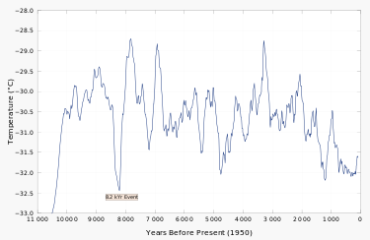
Figure 7: Central Greenland ice core data (Gisp2) reconstructed temperature.

Table Summarizing the Comparison of the Predicted Nemesis 3600-year Sar Cycle with the Kiloyear Events
Predicted 3600-Year Sar Cycles of Orbiting Nemesis Star (BP / BC) | Kiloyear Events for Major Climatic Changes Per Academic Studies (BP / BC) | Years of Lowest Central Greenland Ice Core (Gisp2) Temperatures | Full Range of Years for Actual Effects on Earth (Predicted max.  is 550 years *)
11,500 / 9500 | 11,500 / 9500  Great Deluge or End of Younger Dryas | 11,500-10,500 BP | Used as a baseline.
7900 / 5900 | 8200 / 6200  (called the 8.2 kiloyear) | 8200 and 7200 BP  (with raised levels between these years) | 7900 vs. 8200 BP;  actual large fluctuations of 1200 years ** are indicated.
4300 / 2300 | 4200 / 2200  (called the 4.2 kiloyear) | 4800 and 3800 BP (with raised levels  between these years) | 4300 vs. 4200 BP; actual 1000 years ** of large fluctuations.
700 / 1300 AD | 800 BP / 1200 to 1800 AD  (called the Little Ice Age) | 800 AD and 1300 to 1800 AD  (with raised levels between 800 and 1300) | 1300 vs.1200 AD;  actual 500 years ** of large fluctuation and continuing for another 500 years.
+ 2900 / 4900 AD | N/A | N/A | Effects could occur as early as 4350 AD.
*The predicted full span of years of disturbance is obtained by adding the 100 years of uncertainty for the Sar cycle of 3600 ± 100 years to the span of visitation by Nemesis of 400 ± 50 years or 100 years + 450 years = 550 years.
**The actual years of disturbance are estimated by using the ice core data from Gisp2 shown in Figure 7. This method of only using one parameter of climatic change leads to inaccuracies but aids in seeing how spans of Nemesis visitation inside the Sun’s heliosheath need to be considered.
Note: No lag for recovery of Earth’s climate is considered; factors for variance in lag may be the Sun’s output of energy; orbital perturbations; geological disturbances such as volcanism with subsequent altered atmosphere, and glaciation fluctuation with subsequent altered sea level. All these factors can create sizable shifts in the climatic indicators. But what stands out in this study is the resemblance of a 3600-year Sar cycle.

Why Can the Nemesis Brown Dwarf Star Not Be Found?
This elusive celestial body may vary in size and mass from that of one of the outer planets to the lower limit of 2 to over 300 times the mass of Jupiter for brown dwarfs. Below 13 Jupiter masses (M_{j}) the star is called a sub-brown dwarf or a Y-dwarf due to its theoretical energy output. Brown dwarfs were theorized in the 1960s and verified discoveries were made in 1995. Teide 1 was the first free-floating at 57 ± 15 M_{j} having a 3.78 radius of Jupiter. Since Teide 1’s discovery at 400 light years away, 1,800 brown dwarfs have been discovered. Gliese 229B, a companion brown dwarf to a Gliese 229A - a red dwarf, was confirmed that same year at only 19 light years away. This brown dwarf was measured as 21 to 52 M_{j} or 0.02 to 0.05 solar masses.
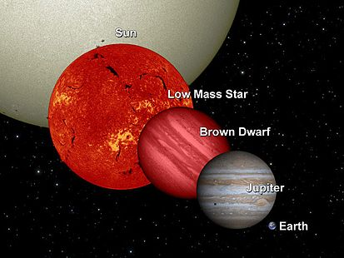
Figure 8: Comparative Size of Brown Dwarfs With Other Types of Celestial Objects

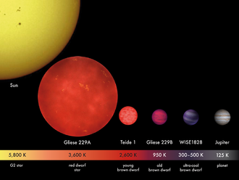
Figure 9: Comparative Sizes of Different Brown Dwarfs Shown Beside the Sun and Jupiter; the Newly Discovered Y-Dwarfs Have Temperatures of About 225 K.
The near-infrared spectrum of these brown dwarfs exhibits methane absorption previously only observed in the atmosphere of the gas giant planets. A connection or similar genesis for these celestial bodies is suspected. Recently discovered 12 light years from the Sun are Epsilon Indi Ba and Bb, a pair of brown dwarfs bound gravitationally to a Sun-like star. In August of 2011, NASA’s Wide-field Infrared Survey Explorer (WISE) discovered six Y-dwarfs with temperatures as cool as the human body or 298 K (25° C/77° F). The coolest at 7.2 light years away was verified in April 2014, as 225 K to 260 K.
In 1999 some brown dwarfs were shown to be X-ray sources having magnetic fields. Their coronas are hypothesized to cease existing below 2800 K and become electrically neutral. Perhaps the stars’ magneto-sheath shields the electromagnetic spectrum except for some of the infrared. In 2013 Hubble and Spitzer space telescopes showed brown dwarf weather of wind-driven, planet-sized clouds. This depiction may be the result of orbiting planets inside a bloated corona sheath. In 2015 the first terrestrial-mass planet was found orbiting a brown dwarf.
In the search for exo-solar planets by NASA, numerous brown dwarfs were found orbiting larger yellow dwarfs such as the Sun. Enough data was collected and studied statistically to show brown dwarfs that orbit within 3 to 5 AU are less than 1 % of the stars with a mass similar to the Sun. This desert region of brown dwarfs is a mystery understandably when related to the nebula hypothesis and accretion disk paradigms. Quite possibly, the electric and magnetic fields generated by both stars create a balance of repulsive versus attractive forces to maintain this average gap of 3 to 5 AU - if they are either formed together or captured. The brown dwarf postulated by this paper does not go any closer than 3 AU as it passes twice through the Sun’s ecliptic plane near the Main Belt of asteroids for each orbit. The Sun’s sister brown dwarf is postulated to have been captured somewhat later in the formation of the Sun due to its highly inclined and elongated orbit.
Another glimpse of our interstellar neighborhood reveals the incredibly far-reaching forces between stars. A red dwarf and known closest star to our Sun is Proxima Centari which orbits the Centari A and B binary system with a separation of 12,950 AU and an orbital period of about 550,000 years. This study tells astronomers that the Nemesis orbital period around our Sun is only a small fraction of all possible orbits that include Proxima Centauri’s orbit.
Given the above information collected by NASA since the 1990’s the following summary is made:
- Nemesis could either be a large planet with its own satellites or a brown dwarf with its own planets.
- If planetary-like, then the size of Nemesis could be comparable to Jupiter in mass and radius. Jupiter’s surface temperature ranges from 165 K to 112 K near the threshold of detectability of 150 K. Given Jupiter’s angular diameter of 29.8” to 50.1”, the expected angular diameter at 100 AU instead of 5 AU will be about 2”. There would be no detectable light from the Sun.
- If Y-dwarf-like, then the size of Nemesis would range from 2 to 13 Mj; the coolest at 3 to 10 Mj were measured at 225K to 260 K which is not that far above the detectable temperature limit.
- If like a typical brown dwarf, then the size of Nemesis would range about 25 to 300 Mj with typical parameters such as Teide 1 of 55 Mj, 2600 K surface temperature (based on theoretical calculations), and 3.78 of Jupiter’s radius.
- The nearest known brown dwarf, Luhman 16, is 6.5 light-years; Kuiper Belt Objects (KBOs) are found roughly between 30 and 55 AU with some as far as 60 AU from the Sun. The true meaning of this simple tabulation is that nothing is known to exist from the Sun between 60 AU and 6.5 light years x 63,000 AU = 410,000 AU except for some Scattered Disk Objects (SDOs). Has NASA honestly and sufficiently searched this vast volume of space surrounding the Sun?
- Brown dwarfs are known to exist by themselves or have companion dwarfs or companion terrestrial-size planets with orbits a few AU or smaller.
- Brown dwarfs are known to orbit Sun-like stars.
- Brown dwarfs are known to display electromagnetic (EM) characteristics such as flaring, changing magnetic fields, and auroras; however, only radio emissions are received during flaring episodes.
- Brown dwarfs are not very luminous at visible wavelengths. Many are known to have surrounding disks of dust and gases. Possibly, the disk is more spherical with a magnetosheath that shields radio and light emissions. The surface temperature of its expanded corona boundary or magnetosheath for many brown dwarfs could be less than the 150 K detectable limit. This lower sheath temperature could be easily lowered and maintained by a brown dwarf’s continued periodic crossing of another magnetosheath such as our Sun.
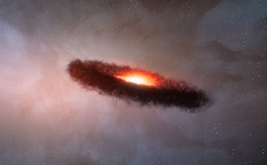
Figure 10: Artist’s impression of a disk of dust and gases surrounding a brown dwarf; more likely, the surrounding materials could be more spherical.

All this recent evidence collected over the past two decades leads most reasonable thinkers to believe in the plausibility of a Nemesis intruder – either a large planet or brown dwarf that is hypothesized in this paper. Is there any evidence of known celestial bodies that would behave similarly to the postulated Nemesis with its very inclined, very elongated orbit? Yes.
A scattered disk object, discovered in 2003, was found to orbit the Sun every 11,400 years in an incline to the ecliptic of 12 degrees. The perihelion is 76 AU with the projected aphelion at 937 AU. Sedna, also considered a minor planet, is listed as having a temperature of 12 K; obviously, a light-detecting device instead of an infrared detector made the discovery. This minor planet’s genesis is a mystery, but the author guesses that there is a direct connection to Nemesis’ trajectory around the Sun.
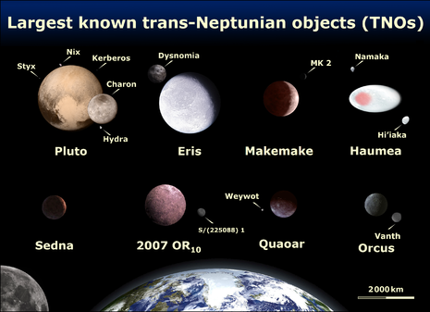
Figure 11: Comparative Sizes of Minor Planets Near and Beyond Neptune

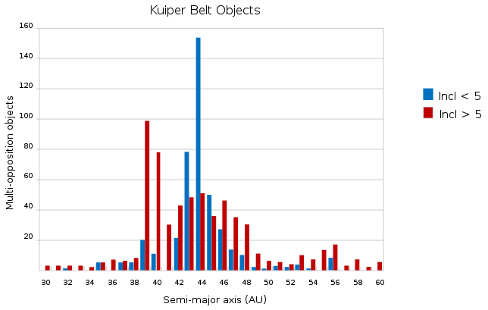
Figure 12: A NASA Generated Chart of Various Populations of KBO’s and Their Locations and Inclinations

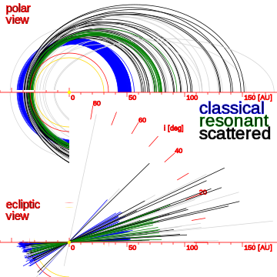
Figure 13: Representation of Solar System’s Asteroids Including the Scattered Disk Objects (SDO’s) Which Are Asteroids in Highly Elongated and Inclined Orbits
Nemesis is postulated to have an inclined orbit of some of the highest inclinations of SDOs of about 20 to 30 degrees which may take it beyond the expected torus of investigation for NASA astronomers. The aphelion is projected to be more than 250 AU with a semi-latus rectum of 3 AU which creates a high ratio for the major to the minor axes of its elliptical path. This very narrow ellipse eliminates the chance for any appreciable proper motion being detected across the sky concerning Earth observers. A computerized algorithm for detecting the proper motion of this star is almost impossible.
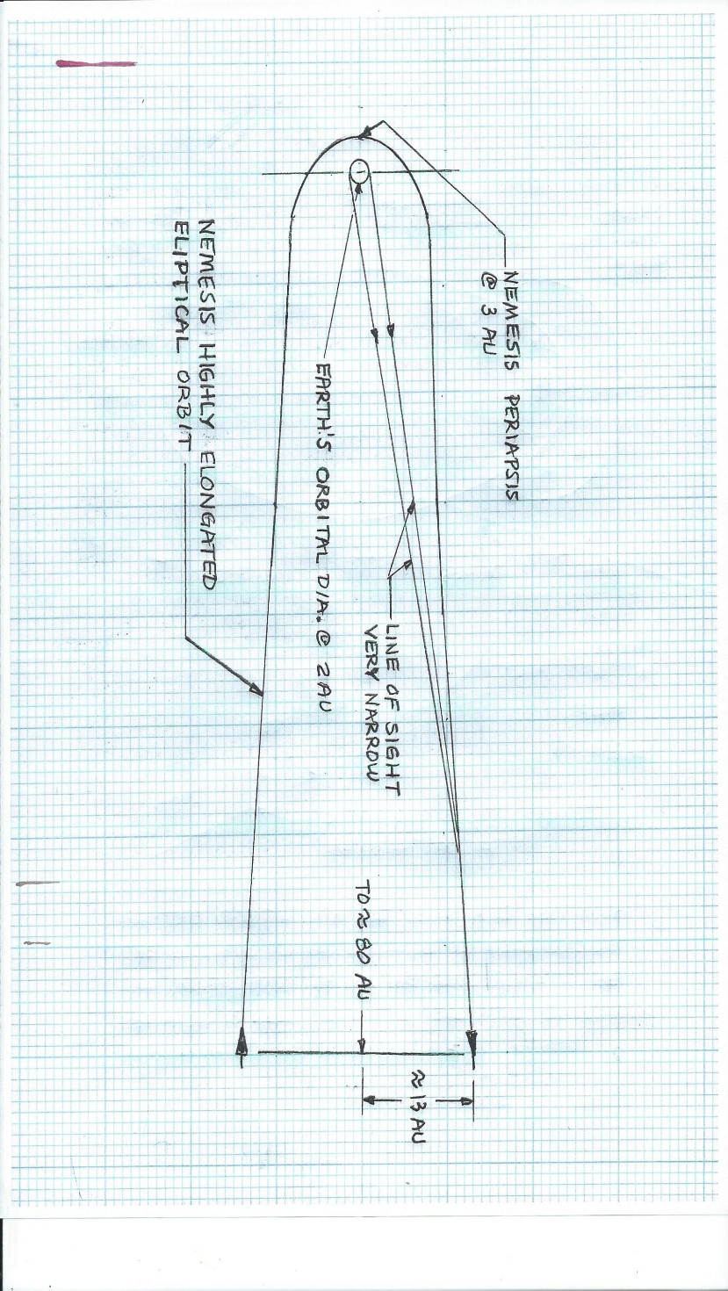
Figure 14: Diagramming the Difficulty of Applying ‘Proper Star Motion’ and/or Parallax to Finding Nemesis on an Extremely Elongated, Inclined, Elliptical Orbit
Optical interferometers using a large array of telescopes can study objects in unprecedented detail such as the surfaces and diameters of stars. They have a spatial resolution of an amazing 4 milliarcseconds. Why not use these optical interferometers to search for Nemesis? Limited aperture area and atmospheric turbulence limit ground-based arrays of interferometers to observations of comparatively bright objects. Hence, the dimmest objects such as Nemesis do not have enough light; this limitation is called the “thinned-array curse”.
The NEOWISE project took photographs of 600 near-Earth objects (NEOs) within 2 AU of the Sun because astronomers were able to combine visible light observations with infrared heat measured by the WISE spacecraft. The Nemesis-type dim star or planet cannot be found this way because no measurable reflected light from the Sun is available.
NASA’s Wide-field Infrared Survey Explorer (WISE) has discovered 100 new brown dwarfs, but astronomers have not yet examined the immense quantity of data. Almost ¾ of a billion objects (asteroids, stars, and galaxies) have been photographed. Infrared wavelengths have been scanned from January 2010 to February 2011 for the entire sky about 2.0 times. A six-month gap between scans enables astronomers to compare the surveys for moving objects. When candidates are selected due to their motions NASA’s Spitzer Space Telescope helps to confirm and narrow the list using such methods as parallax. Telescopes on Earth are then able through spectrometry to identify expected molecular signatures of water, methane, and ammonia for many of the brown dwarfs. Objects that meet the parameters of brown dwarfs are selected with the help of devices called CCDs that can automatically choose objects with certain infrared intensity and proper motion for the observer. The arduous task of comparing photographic plates is no longer necessary. For certain distances from the Sun, a certain combination of these parameters is expected. The visual clue and algorithm are that over time the faster object is considered closer and the slower object is considered farther away similar to observing planes flying at different altitudes. However, a celestial object on an extremely elongated orbit such as the Nemesis system will seem to be much farther away because the proper motion is seen as much less than expected. See the following diagram for the dilemma of enough proper motion.
Photometry is an astronomical method of determining the distance of various celestial objects from Earth. The object’s apparent brightness magnitude is compared with its known absolute brightness. Then the inverse-square law is applied that defines how energy flux decreases with distance. However, for the recent discovery of brown dwarfs with all their variations in theories of energy output and possible shielding by dust and gases or by a special expanded corona, the absolute magnitude of brown dwarfs is still a mystery.
A summary of the major difficulties for NASA scientists finding Nemesis are:
- Extreme dimness allows only the best-performing infrared telescopes to be used.
- The outer envelope of certain brown dwarfs may be too close or below the detectable limit of 150 K.
- Many brown dwarfs have surrounding disks of dust and gases that may shield other electromagnetic signatures from being emitted. X-rays are only emitted when certain brown dwarfs begin to flare indicating that an envelope if not broken does shield EM signals.
- The possibly very short proper motion due to Nemesis’ elongated trajectory may either make it impossible to be selected as a candidate, or astronomers confuse its location as being much farther away.
- Photometry, the process of using the inverse-square law, cannot be applied with any accuracy for brown dwarfs.
- The enormous amount of data has not all been analyzed fully or properly.
- The paradigm of discounting brown dwarfs just outside the Kuiper Belt can cause certain data to be labeled anomalous and mysterious. Such data may be shelved for later analysis.
Dramatically, NASA’s online website headlined, “NASA’s WISE Survey Finds Thousands of New Stars, But No ‘Planet X’“ in March 2014. This hypothesized planet also dubbed Nemesis or Tyche was reported to not exist beyond the orbit of Pluto. The following diagram was produced to show the WISE-detectable region where no bodies larger than the outer planets exist. This unlikely conclusion was given by Kevin Luhman of the Center for Exoplanets and Habitable Worlds at Penn State University in Pennsylvania. However, conflicting statements are made. The ‘Planet X’ search was based on extinction events millions of years apart and also on irregular asteroid and comet orbits. NASA admits that each new study of the data reveals celestial bodies missed in previous studies. And, in 2013, WISE was reactivated to look for potentially hazardous near-Earth objects (NEOs). Very recently in August 2015 the Jet Propulsion Laboratory (JPL) released a news item: “Tracking A Mysterious Group of Asteroid Outcasts”. Much interest developed in finding the source of the Euphrosyne family of dark asteroids, KBO’s, on highly inclined orbits in the outer asteroid belt. Apparently, for NASA and JPL the interest and/or concern for Planet X or Nemesis has not gone away.
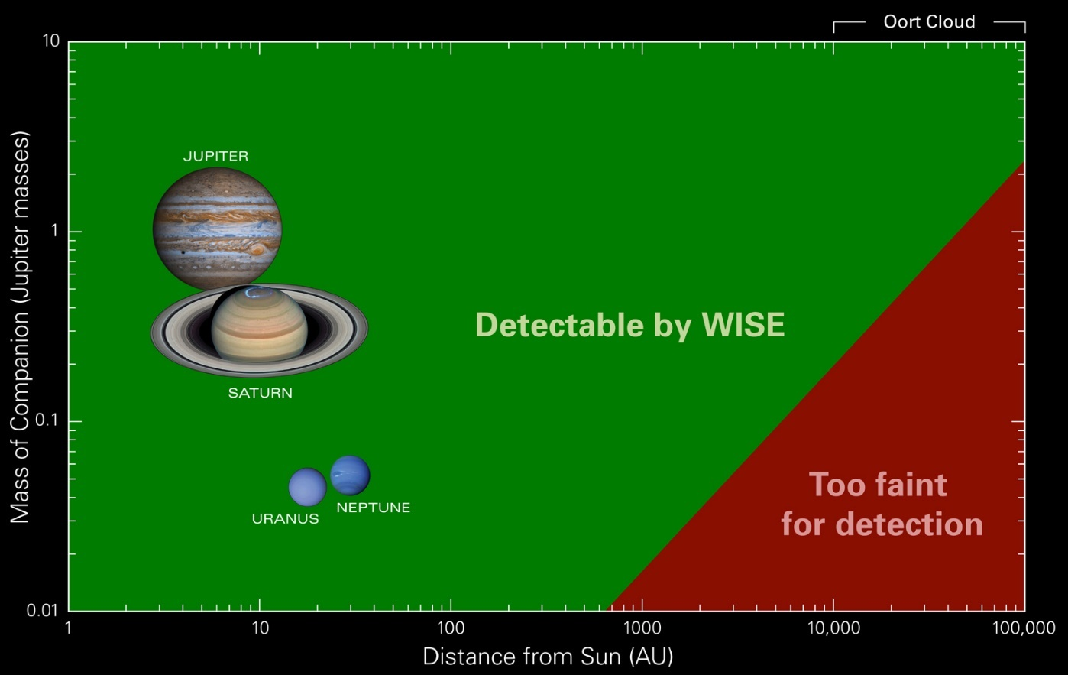
Figure 15: NASA’s Representation of the Detectable Region for WISE Infrared Sky Survey; this diagram assumes that no body is near or below the threshold of 150 K detectability and closer bodies have enough proper motion to be selected for analysis.
What if Nemesis has already been discovered and its information is classified? Would the governmental authorities who rule over NASA worry about the release of such information to the public? Would the public become so shocked and unstable knowing that impending global disasters on Earth may occur in 10’s or 100’s of years? Some conspiracy theorists even conjectured that parts of the Google southern sky are blocked out due to NASA orders. These possibilities may exist due more to this author’s suspicions coming from another source, the study of forensics in the solar system.
NASA and ESA space probes to all the planets and most of their satellites, to comets and asteroids, and the magnetosheath of the Sun reveal a very distinct reality that is being currently denied. The majority of surface features on these objects indicate the result of electromagnetic phenomena that overshadow the conventional idea of asteroid collisions. These surface features, as promoted by an independent group of scientists associated with the Electric Universe.com prove that very energetic plasma arc discharges have occurred. The configurations of these features, especially those well photographed on Mars, reveal precisely what can be duplicated in the study of plasma in laboratories on Earth. NASA and JPL have remained strangely silent on this matter. The Electric Universe people simply accuse consensus science of being caught in the paradigm of the impossibility of lightning-type electric currents or plasma passing in a vacuum of space between closely passing celestial bodies inside the solar system. And, of course, for NASA the only close encounters are between planets and asteroids. But, the evidence for electrical and magnetic forces creating and maintaining the stability of the solar system keeps mounting. The study of changing solar winds; witnessed electrical discharges on comets, on the Moon, and Jupiter’s Io; planetary auroras correlated to solar winds, and the magnetosheaths of the Sun and planets all point to EM phenomena ruling interstellar and interplanetary environments.
The major question for this paper is what has caused these countless disruptions of planetary and satellite surfaces by electrical means. Postulating that planets and stars carry a varying unbalance of electrical charge, their close encounters over millions of years will cause lightning bolts between the two passing objects just as happens between Earth’s surface and clouds. And, how do close encounters occur? The Nemesis hypothesis creates these close encounters on an approximate periodic basis over millions of years if its orbit carries itself and companion planets through the Sun’s planetary system. As part of the hypothesis, the periodic disruptions will result in a myriad of results for each period due to different planetary locations and different exchanges of electrical charge. Hopefully, NASA and JPL will begin a dialogue with the Electric Universe scientists shortly.
The most important criticism of this paper’s Nemesis hypothesis is the plausibility of orbital mechanics proving that such an orbit is possible with the given gravitational forces that certainly cannot be denied. Furthermore, can this orbital combination of the two stars with their planets remain stable over thousands or millions of years? Consideration for orbital mechanics will now be addressed.

Is the Nemesis Hypothesis Realistic in Terms of Orbital Mechanics?
Orbital mechanics applies practical problems of the motion of rockets and spacecraft including natural astronomical bodies such as star systems, planets, moons, and comets. Their motions are calculated from Newton’s laws of motion and Newton’s law of universal gravitation. General relativity is a more exact theory but is only necessary for greater accuracy or in high-gravity situations such as orbits close to the Sun and near-Earth orbits of spacecraft and artificial satellites. Johannes Kepler published a model for planetary orbits in 1605 and Newton’s more general laws were published in 1687. Kepler’s Laws can also be applied to the simple case of the Nemesis star or planet orbiting the Sun without the complications of other companion planets or moons.
In chapter four of this paper, Kepler’s Third Law was misapplied and will be corrected. The equation used was –
G x m x t² = 4 π² x r³
where G is the universal gravitational constant, m is the mass of the Nemesis object, t is the orbital period and r is the orbital radius. The corrected equation is
G x (m + M) x t² = 4π² x r³
where the additional quantity is M, the mass of the Sun. In this corrected equation, the mass of the Sun completely overwhelms the smaller masses of either an outer planetary mass such as Jupiter or a brown dwarf mass such as the chosen typical Teide 1’s mass.
The examples chosen for Nemesis will be a planet that is 2 times the size of Jupiter (0.00192 x mass of Sun) and a brown dwarf the size of Teide 1 (0.0544 x mass of Sun). Hence, the gravitational parameters of u = G (M_{sun} + m_{2j}) = G (1.00192 x M_{sun}); and u = G (M_{sun} + m_{Teide1}) = G (1.0544 x M_{sun} ) are hardly distinguishable from each other. The simplified Kepler’s Third Law equation using periods and orbital radii can be applied as before –
P₁² / P₂² = R₁³ / R₂³
where the Nemesis period of 3600 years is utilized and r₂, the approximate radius of Nemesis’s orbit is 234 AU assuming a round orbit. The other orbital radii would be 246.7 AU for a typical brown dwarf and 234.4 for a typical planet the size of an outer planet.
The above calculation does not consider the elongated ellipse that is postulated. For this approach, the latus rectum = L of its elliptical orbital path is used as a datum point. That suspected datum point is where the Nemesis system crosses the ecliptic plane of the solar system planets near the Main Belt of asteroids between Mars and Jupiter. This distance is chosen at 3 AU although the average distance of Main Belt asteroids is 2.7 AU. The crossing of Nemesis at these two points on its inclined orbit is thought to continue for millions of years and maintain the Main Belt; this orbital possibility will be called Version #1. Conventional thinking is that nearby Jupiter caused gravitational resonances and prevented these asteroids from either dispersing or combining together over millions of years. Consensus science also believes that the asteroids were originally part of the residual accretion of the primordial disk of dust that rotated around the proto-sun. However, the space probes have proven that these chunks of matter look much like debris caused by collisions or high energy plasma arc sputtering of existing hardened celestial bodies.

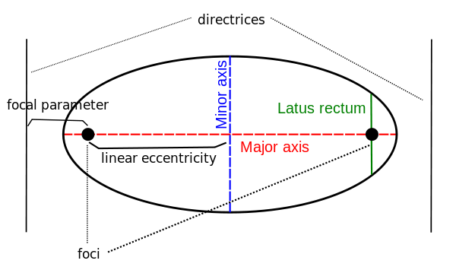
Figure 16: Ellipse parameters showing major and minor axes and the latus rectum.

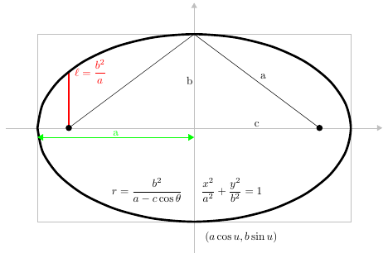
Figure 17: Standard forms of an ellipse from internet’s online topic of Conic Sections
Other possibilities or versions for orbital trajectories are that of Version #2 - the periapsis of Nemesis is 3 AU thereby hovering over and disturbing the Main Belt during each periapsis of its orbit; and Version #3 - the periapsis is about 30 AU from the Sun and very close to Neptune’s orbit but well outside the ecliptic plane due to its inclined orbit.
The calculations for these orbital paths begin with the given orbital period of 3600 years and the gravitational parameter of –
u = G (M_{sun} + m_{Nemesis})
where G is the gravitational constant = 6.673 x 1011 m³/kg x s²; M_{sun} = mass of Sun = 1.989 x 10³⁰ kg; and m_{Nemesis} = mass of a typical brown dwarf (Teide 1 is chosen, which is 0.052 times the mass of the Sun.
Hence, the gravitational parameter in this case is –
u = 13.963 x 10¹⁹ m³/s²
For a larger brown dwarf such as Gleise B the gravitational parameter is –
u = 14.281 x 10¹⁹ m³/s²
For a typical outer planet such as Uranus being Nemesis the gravitational parameter is –
u = 13.273 x 10¹⁹ m³/s²
As is indicated above, the mass of Nemesis, if it is either as massive as a brown dwarf or as an outer planet, does not affect its orbital path as much as the Sun’s mass and the predicted orbital period of Nemesis.
Utilizing the equation for the orbital period for an elliptical path will reveal the major axis, 2a –
T = 2π x (a³/u)^{1/2}
a = 3.57 x 10¹³ m = 238 AU, and
2a = 476 AU = major axis
Letting L, the semi-latus rectum, equal 3 AU and the semi-major axis = 238 AU for Version #1, the following operations are performed –
L = b²/a, and
b = semi-minor axis = 26.7 AU;
c = (a² – b²)^{1/2}, and
c = linear eccentricity = 236 AU;
r_{p} = periapsis = (a – c)
r_{p} = 2 AU
which means that Nemesis comes close to the Martian orbit Main Belt of asteroids but never approaches the outer planets.
In the case of Version #2, let the periapsis, r_{p} = 3 AU and a = 238 AU, then the following operations are performed –
c = a – r_{p} = 235 AU, and
b = (a² – c²)^{1/2} = 37.7 AU, and finally
L = semi-latus rectum =b²/a = 6 AU
which means that Nemesis comes close to Jupiter with an orbital radius of 5.2 AU, but is away from the ecliptic plane.
For Version #3, let the periapsis, r_{p} = 30 AU, making the resulting apoapsis, r_{a} = 476 – 30 = 446 AU. The following operations are performed –
c = a – r_{p} = 208 AU = linear eccentricity, and
b = (a²-c²)^{1/2} = 115 AU;
L = b²/a = 55.6 AU
which means Nemesis stays well outside the orbits of the Sun’s planets. Its effect on the solar system would be possible perturbations of its own planets or satellites, the consequences of barycenter changes, and the electrical field effects of the Sun and Nemesis passing through each other’s magnetosheaths. This version provides the most possible stability of the system over much longer periods of time such as millions of years. A table and diagrams shown approximately to scale are provided to summarize the orbital characteristics of these three plausible orbital modes.

Table of Orbital Characteristics in AU Units
for Different Predicted Paths of Nemesis
Version | Semi-major axis (a) | Semi-minor axis (b) | Linear ecc. (c) | Semi-latus rectum (L) | Periapsis  (r_{p})
#1 | 238 | 26.7 | 236 | 3 | 2
#2 | 238 | 37.7 | 235 | 6 | 3
#3 | 238 | 115 | 208 | 55.6 | 30

The question still remains whether any of these overlapping celestial systems are stable over thousands and millions of years. Certainly, the closest encounters and multi-conjunctions or alignments of several planets and a star will lead eventually to wild perturbations over large intervals of time with repeated orbital crossings. Computerized simulations of these Nemesis’ orbitals paths based strictly on Newton’s laws of motion and his universal gravitation equation will certainly indicate natural instability. But, are these simulations interpreting nature properly?
Version #1: Diagram to Scale of Nemesis’ Orbital Path with a Periapsis of 2 AU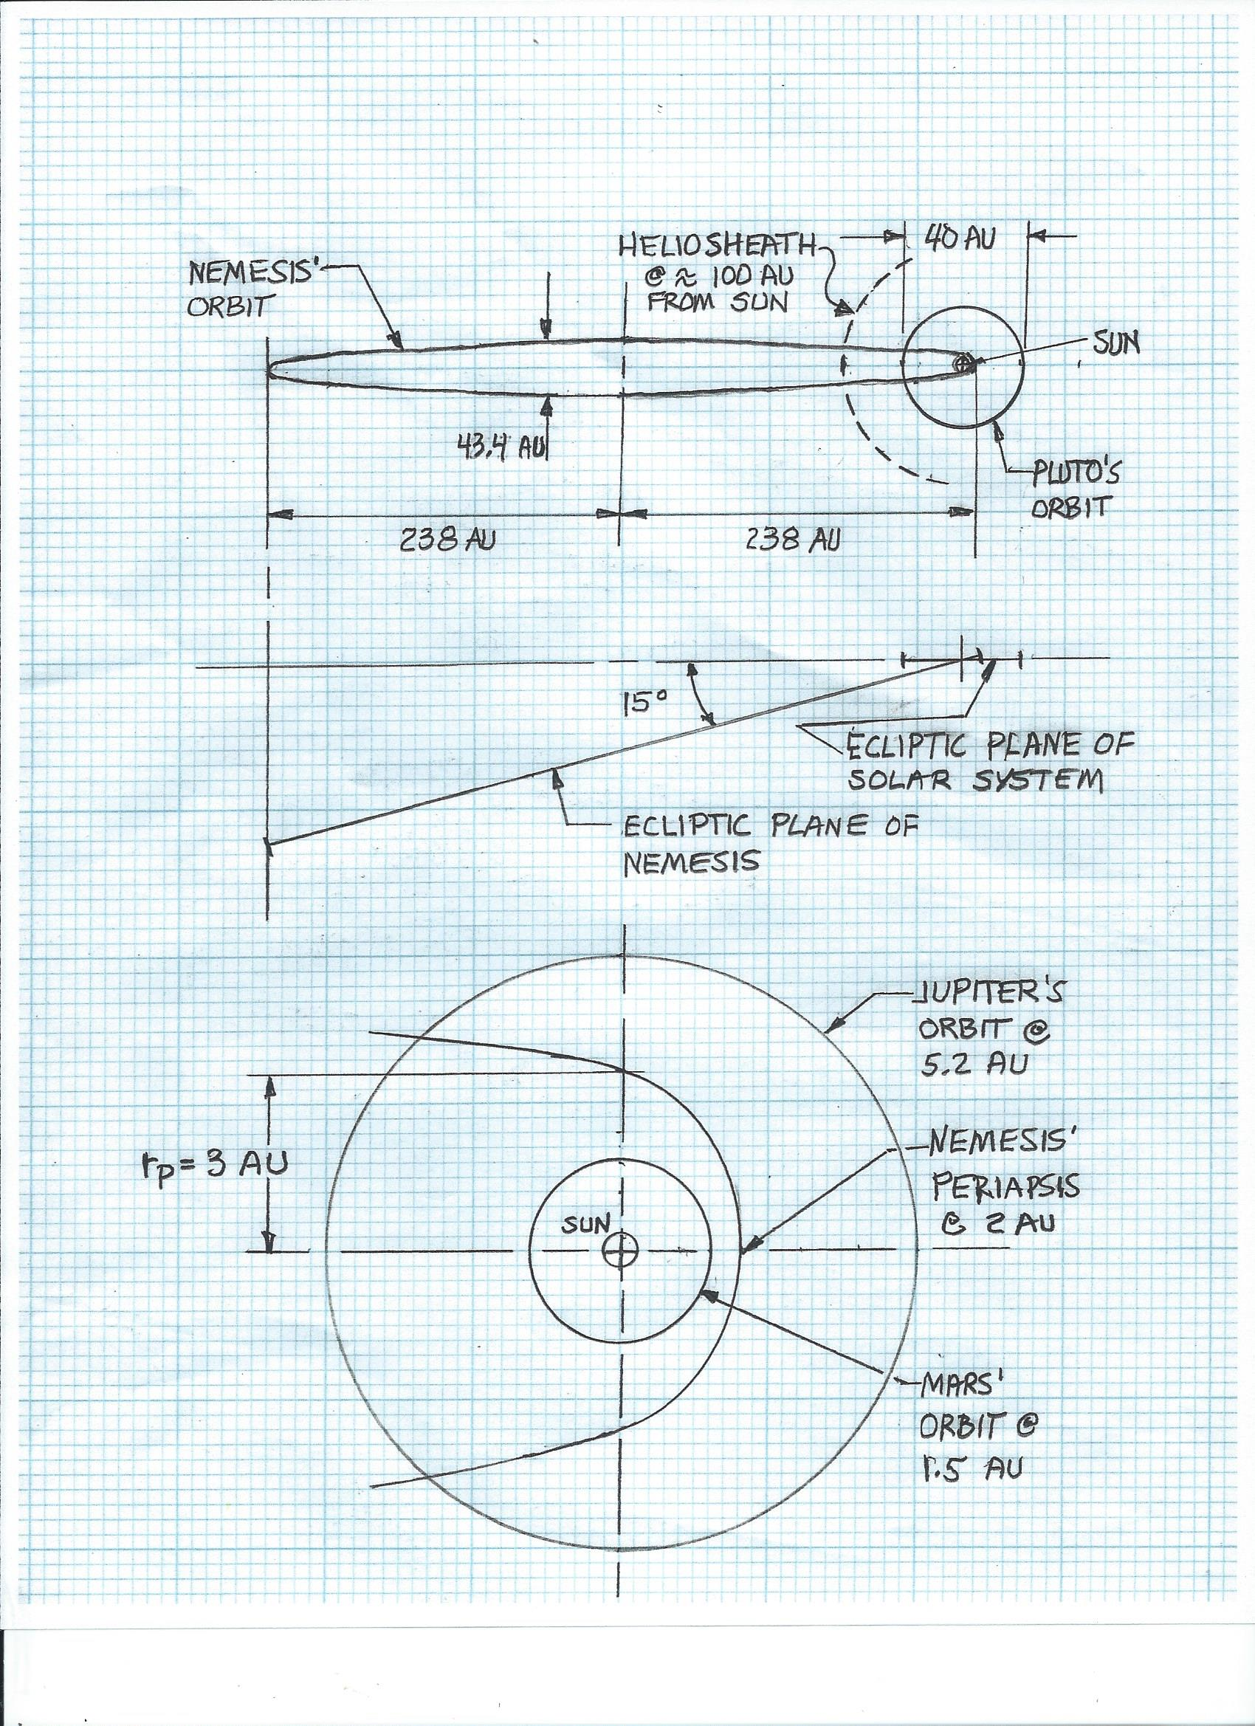
Version #2: Diagram to Scale of Nemesis’ Orbital Path with a Periapsis of 3 AU
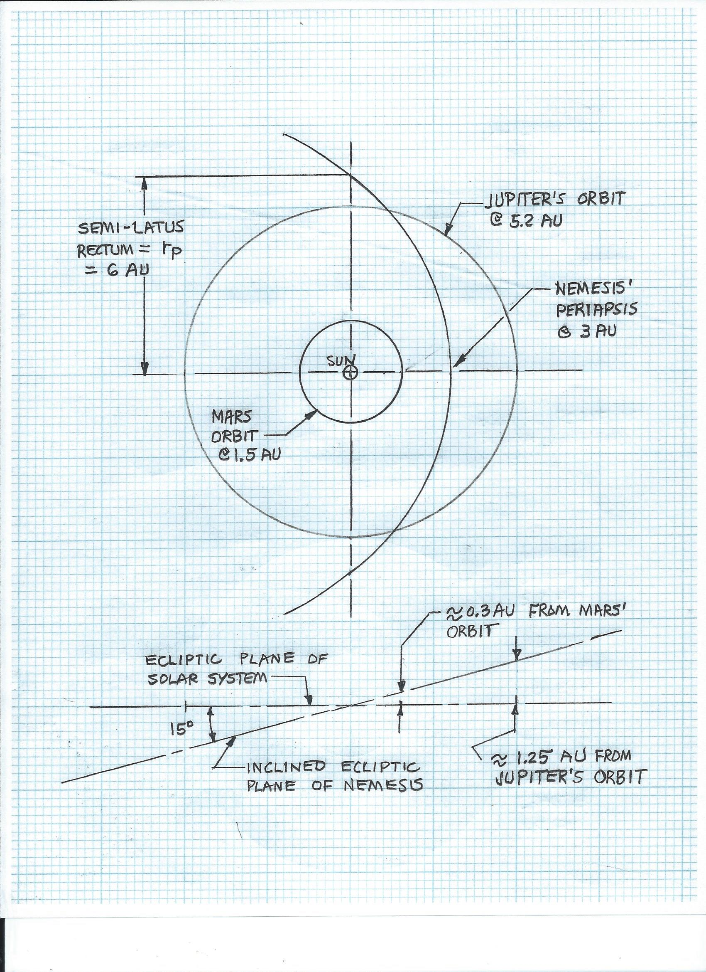
Version #3: Diagram to Scale of Nemesis Orbital Path with a Periapsis of 30 AU
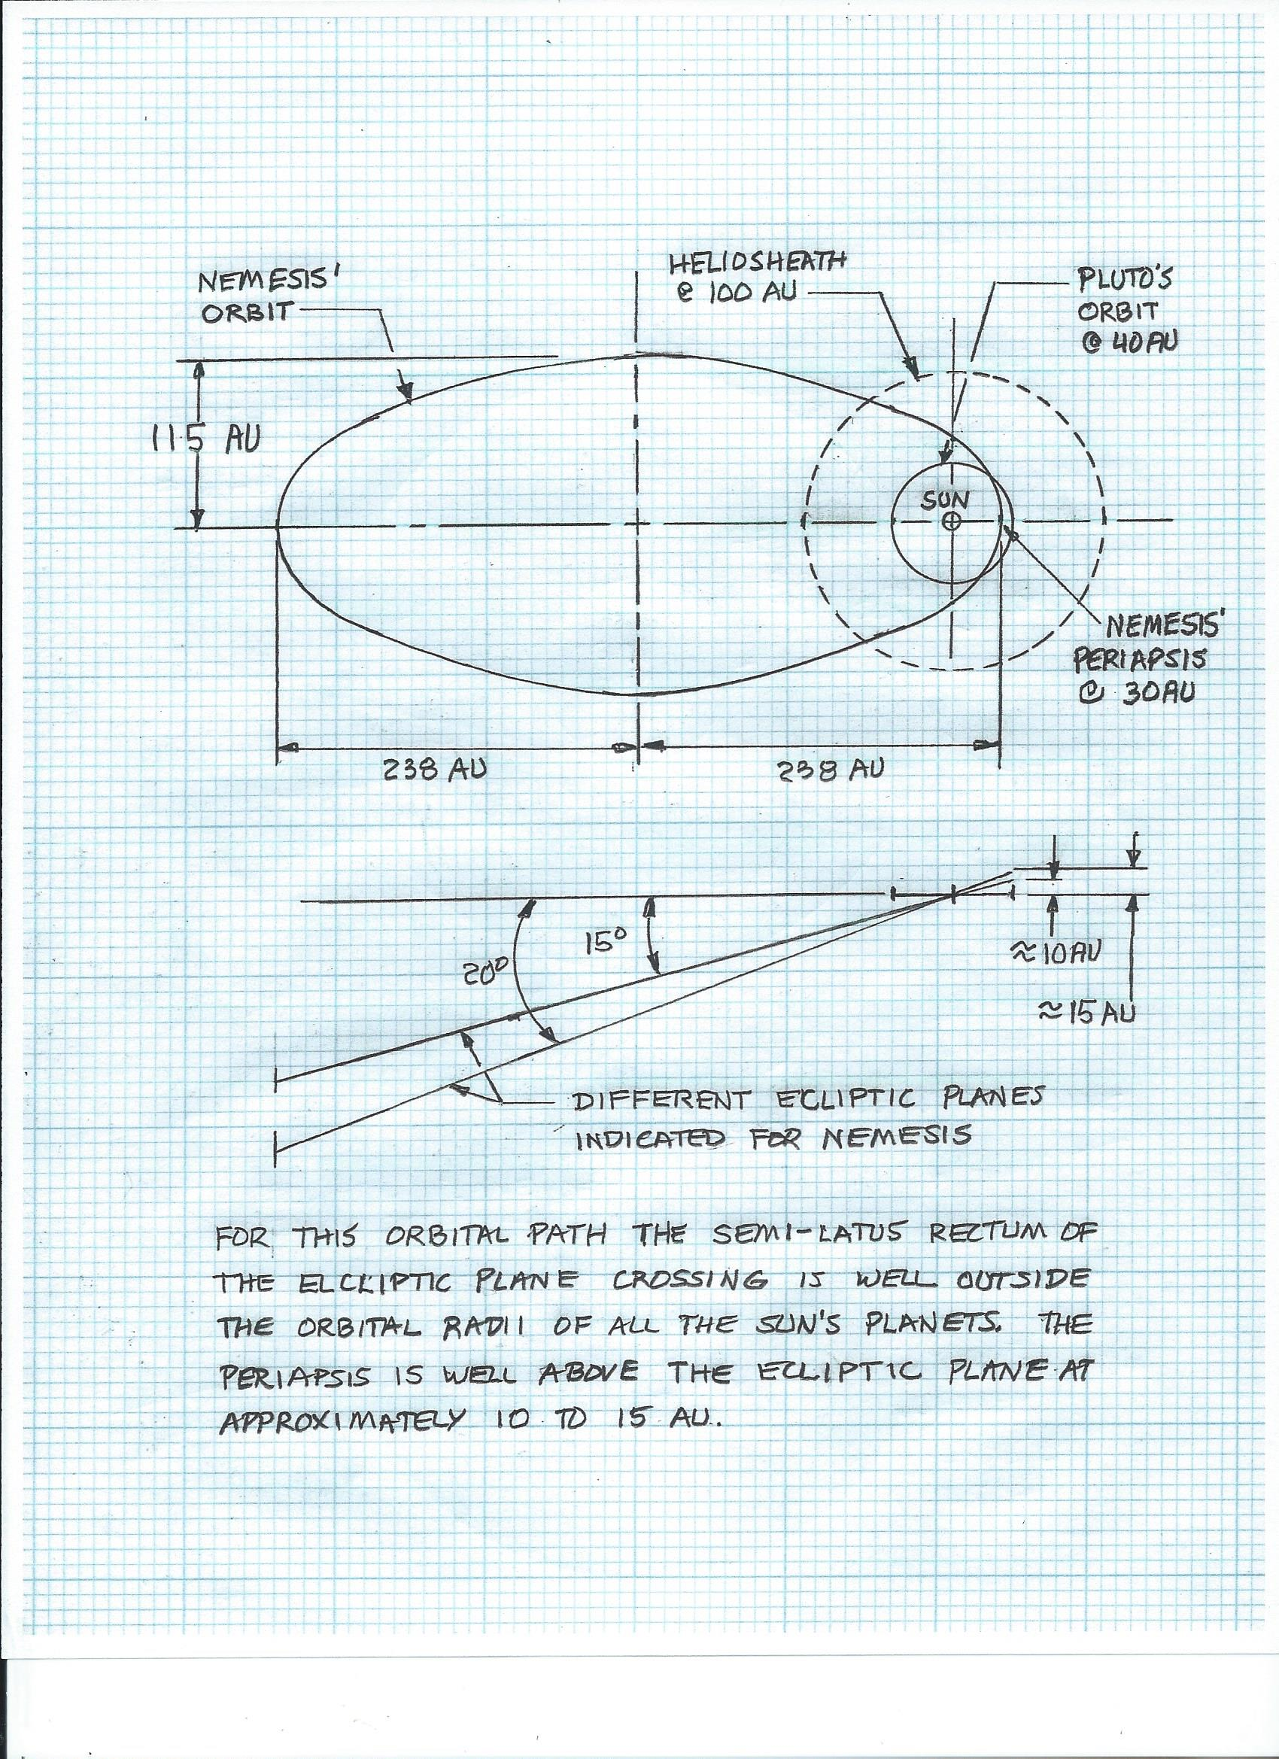

The Stability of a Binary Star System Such as the Sun and Nemesis
The stability of a planetary system like the Sun’s is an unshakable paradigm. How can life evolve on planet Earth unless there were millions of years for planets to have stable orbits and for the Sun’s radiation output to be relatively unchanged? However, the Earth’s glaciation periods and mass extinctions indicate periods of catastrophism and instability. Also, a review of asteroid and high energy arc strikes on other planetary and moon surfaces, the rings around the outer planets, the irregular shapes of comets and asteroids, of the highly inclined and elongated orbits of comets all indicate instability throughout the entire solar system during the eons of time of its existence.
The introduction of a Nemesis brown dwarf star orbiting the Sun every 3600 years is very difficult to accept since the vision of any planetary stability and the concept of uniformitarianism on Earth would be lost. But this need not be the case. Of course, occasional catastrophism such as major glaciation, aridification, and flooding has occurred as is well documented. Better reasons for such events on Earth need explanations such as the returning Nemesis over short periods that are not yet accepted by consensus science. But then, how can astrophysicists explain why a stable planetary system still exists? The answer is that not all the laws of nature have been considered.
Consensus science only considers gravitational and kinetic reasons for how celestial motions are determined. Presently, the scientific community rules out that electrical and magnetic forces on a star-system scale dominate over gravitational forces. If one simulates the solar system on a computer using only Newtonian concepts, perturbations between the planets and their moons eventually become disturbed enough to cause chaos in the system. NASA has no answer except to say that this puzzlement is yet to be solved. The only answer is that other forces, not addressed, are maintaining the system. The Sun with its magneto-sheath and solar winds, the planets with their magneto-sheaths and general changing charge unbalances act like electrical circuitry to restore the orbital radii if they are perturbed such as would happen when Nemesis and its planets come close to the planetary orbits of the Sun. The independent scientists of the ElectricUniverse.com claim that there is an unbalance of charge occurring between the planets and between the planets and the Sun with its positive charge. A massive electrical circuitry and equilibrium of charge is always working to maintain certain distances between planetary bodies and the Sun. This paper contends that after Nemesis cruises through the Sun’s magnetosheath and its planetary system, orbital perturbations do occur, but are soon returned to normal after Nemesis leaves. Ample time is available for affected electric and magnetic fields to reach equilibrium once again and preserve the orbital shapes and distances of the various planets. Of course, very infrequently during a crossing of Nemesis a close encounter and/or violent exchange(s) of plasma energy will occur causing calamity.
The study of close multi-star systems and exo-solar systems and hot Jupiters well inside Mercury’s orbital distance from stars reveals that stability does exist under extreme conditions when gravitational forces fail to explain their genesis or continuance. Electrical forces are controlling these celestial bodies on a macro-scale and this is why astronomers can observe so many at any one point in time. These same electrical forces control the particles inside matter on a micro-scale. Orbiting systems, no matter what their scale are kept stable by electrical forces that unify the entire universe. Gravity is a minor actor except for mankind’s experiences on Earth and with his space probes in space.
In conclusion, a star system with all its attendant celestial bodies is controlled significantly more by electromagnetic forces than by gravitational forces. This concept is why an elongated orbit of a Nemesis star around the Sun can be stable for millions of years and possibly the life of the solar system discounting some infrequent incursions of close encounters. These close encounters and possibly some collisions result in calamity that quickly subsides and is forgotten. Only certain surface features on these celestial bodies and Earth’s climate data show a record of these violent visitations.

Conclusions about Nemesis
Does Nemesis exist? Does Nemesis orbit the Sun and affect its planets? Is there any possible series of events known on Earth that give a rough record of Nemesis’ visitations? Do these events indicate a cyclical nature? Are there good reasons why the NASA and ESA programs cannot find this ubiquitous rogue? Can the stability of the Sun’s planets and its orbiting sister star be explained by natural factors other than just gravity? Are there plausible reasons why the people in control of the space programs may not want to make Nemesis public if it has already been discovered? The answers to all these probing questions are “yes”.

