Astrophysics Quiz No. 18: Asteroids Do Not Lie to Us.
1. What type of meteorite is considered to have the elemental composition of the Sun more so than any other meteorite? And what type of asteroid is its origin? _______________________________________________.
2. The most common type of meteorite, CI chondrites, are named after which meteorite? ____________________________________________.
3. What basic insight do CI chondrites which contain minor amounts of frozen water, organics, and lighter elements/compounds provide? _______________.
4. The Chicxulub impactor that is claimed to kill the dinosaurs came from a - a. comet; b. C-type chondrite asteroid; c. Kuiper Belt object; or d. S-type asteroid.
5. What is the difference between carbonaceous (CC) and non-carbonaceous (NC) asteroids? a. have basic isotopic differences; b. come from different reservoirs, one inside and one outside the orbit of Jupiter; c. temperature differences in their formation.
6. Why did NC and CC asteroids become mixed after many millions of years?
______________________________________.
7. Why did the idea of comets or “dirty snowballs” bringing water to Earth fall out of favor? a. Comets come from the outer solar system due to their highly elliptical orbits; b. Outer solar system’s frozen bodies including comets from space probe imaging were determined to have non-carbonaceous isotope ratios unlike the water isotope ratios found on Earth; c. explored comets were discovered to be mostly dehydrated; d. because of all the above reasons.
8. The latest consensus theory for water’s origins is that “the late-stage accretion of CC asteroids to Earth is sufficient to account for the entire budget of Earth’s water and other highly volatile species. (from Space Serious Reviews, Volume 216, May 2020 under the topics of isotope anomalies and NC-CC dichotomy.)
However, this newest theory is problematic for what reasons? a. There is no reason why Earth would be especially targeted as opposed to the other inner planets and the Sun; b. Space probes sent to carbonaceous asteroids indicate a sparsity of water that would require an improbable number of millions of collisions to achieve Earth’s water inventory; c. There are no attendant reasons that are provided for the nitrogen and CO2 atmosphere inventories; d. Reasons are lacking for why water deep within the mantle did not already differentiate early and be boiled away by the heat of the proto-star T-Tauri phase; e. All the above reasons apply; f. All the above reasons except c and d.
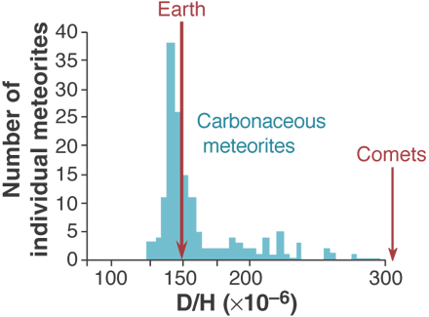
Graph showing the D/H isotopic parameters of meteorites compared to comets.
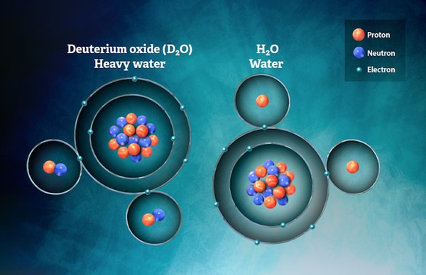
Isotopic differences of D20 and H20 for water that distinguish CC and NC asteroids.
Answers:
1. CI chondrite; carbonaceous asteroids
2. The Ivuna meteorite begins with the letter “I”
3. Materials that made up the earliest days of the solar system; however, the irregular shapes and dispersal appear that the collisions predominated over accretions.
4. b. C-type asteroid
5. a and b
6. The supposedly outward migration of the outer planets thus disturbing Kuiper Belt Objects (KBOs) that then moved sunward.
7. d. All the above reasons.
8. e. All the above reasons.

