Astrophysics Quiz No. 19: How are the chemical elements created?
- What is nucleosynthesis?
a. The process that creates nucleons and leptons.
b. The process that creates atomic nuclei.
c. Creation of protons and neutrons without electrons.
- What process produces all matter including dark matter as predicted by consensus science?
- Supernovae
- The Big Bang
- The atomic fusion process of cores inside stars.
- What nucleosynthesis process created most of the elements with atomic numbers higher than iron Fe that actively decay?
- Stellar
- The hot corona of stars
- Supernovae

- Most normal matter is in what form?
- Plasma
- Neutral atomic nuclei
- Mostly leptons that are include electrons, muons, and neutrinos.

- Why was the Big Bang adopted?
- ¹₂H, Li, Be, B and a high amount of He cannot be produced inside stars.
- The existence of deuterium, an isotope of hydrogen
- Existence of nuclides between helium & carbon in the periodic table.
- All the above.

- What is the primary source in present time of the initial Big Bang elements: Li, Be, and B?
- Meteorites.
- Comets.
- Cosmic rays
- All the above.

Chief Nuclear Reactions During the Big Bang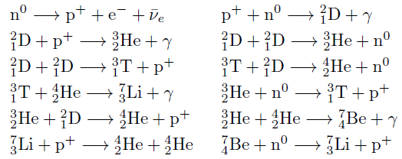
- Production of the first matter is neutrons (n⁰)
- Neutrons split to create protons, p⁺, and electrons / neutrinos, e⁻ / ѵ_{e}
- A proton + neutron combine to form a hydrogen isotope ²₁D (deuterium) & a photon.
- ²₁D (deuterium) + proton( p⁺ ), produces helium isotope, ³₂He, and a photon.
- Another sequence of combinations eventually creates small amounts of Li Be and B.

Answers: 1.- b; 2.- b; 3.- c; 4.- a; 5.- d; 6. - g

