Astrophysics Quiz No. 15: Have Fun Mooning Around
(Please fill in the blanks: the answers will be provided on another page.)
1. The approximate number of known asteroid satellites exceeds what amount?
2. The largest six satellites in the outer solar system are which ones?
3. Name a high density-ratio duo in the outer solar system like the Earth/Moon duo.
4. What satellite is captured by the Sun’s gravity field instead of its parent body?
Do your own calculations using Newton’s Universal Gravitational equation if you do not believe it. ( F = GxMxm / r² )
5. Name the six most abundant frozen volatiles per atmosphere analyses found on outer solar system satellites.
6. Name the three major categories of satellites found in the solar system. Which category is the fastest and why?
7. What moon of Saturn has a deep hexagonal crater almost 1/3 its diameter?
8. What moon of Jupiter has a deep conical crater almost ¼ of its size?
9. What is the term given to a captured body that orbits too close to a parent body and breaks into pieces as it eventually falls to the surface?
10. What is the term used for explaining why certain moons always face the same way toward their parent body as it orbits?
11. What process causes the larger moons to be spherical?
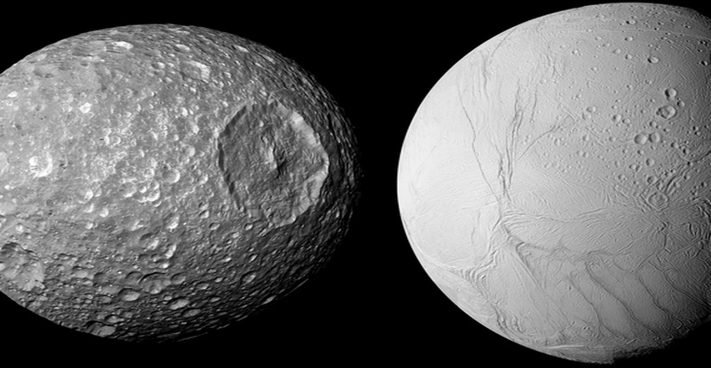
Hexagonal crater ¼ size of this moon???? Maybe Darth Vader’s Death Star.
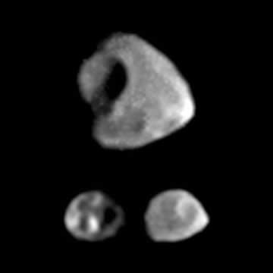
Scalloped crater 1/3 the size of its moon??? Someone maybe used an ice cream scoop?
Answers:
1. Over 200.
2. Io, Europe, Ganymede, Callisto, Titan, and Triton.
3. Pluto and its moon, Charon.
4. The Earth’s Moon.
5. H20, CO2, N2, NH3, CH4, and SO_{x} which are also common volatiles on Earth
6. Regular, irregular, and artificial. The artificial ones are the fastest because they are very close to the planets surface.
7. Mimas.
8. Thebe.
9. The Roche Limit.
10.tidal locking.
11.hydrostatic equilibrium.

