Astrophysics Quiz No. 16: Moons Of the Planets Reveal the Truth
(Please fill in the blanks; the answers will be provided on another page)
1. How do we know that the large bodies in the solar system are spherical and suspended in the ether of space? _______________________________.
2. How do we know that moons orbit planets leading humankind away from geocentric and anthropocentric concepts? ___________________________.
3. What revealed first that the other celestial bodies had mountains and ridges and plateaus like Earth? ___________________________________.
4. The orbiting Moon that never fell to Earth convinced Newton to invent what cosmic force? __________________________________.
5. What regular moons in the solar system largely invalidate the Nebular Hypothesis in which smaller bodies are formed around larger central bodies due to particle acretion? _____________________________________________.
6. Why is the Moon’s origin coming from Earth so difficult to justify by both the basis of mechanics and geometry? ______________________________________.
7. Why is the Moon’s origin by capture problematic? ____________________.
8. What idea has NASA finally decided for the Moon’s origin due to the issues of a binary or capture mode? _________________________________________.
9. Although NASA’s collision mode of a glancing rogue body slows down a passing body for its capture, what are some of the glaring contradictions? ____________
__________________________________________________________________.
10. Are there other Moon origins not yet considered or not popular? __________.
11. What are the origins of the smaller, irregular moons that have strange orbits around the outer planets? These captured irregular moons have many shapes, sizes, and resemble asteroids. ______________________________________.
12. Perhaps modern humankind should call these outer giant planets the Great Protectors or Gods for they corral these dangerous bodies and prevent them from entering the inner solar system and doing great harm to Earth. One memorable example of the capture of one of these bodies was the breakup and collision of which comet into what planet. ___________________________________.
13. Download the imaging of “all of Saturn’s moon size comparison” by Nerdist.com . Google this topic and see how Saturn’s 83 moons escalate quickly. Then Google “Asteroid Impact Comparison” by Metaball Studios only if you are not frightened too easily. But you will understand why the outer planets should be venerated as Gods that protect Earth.
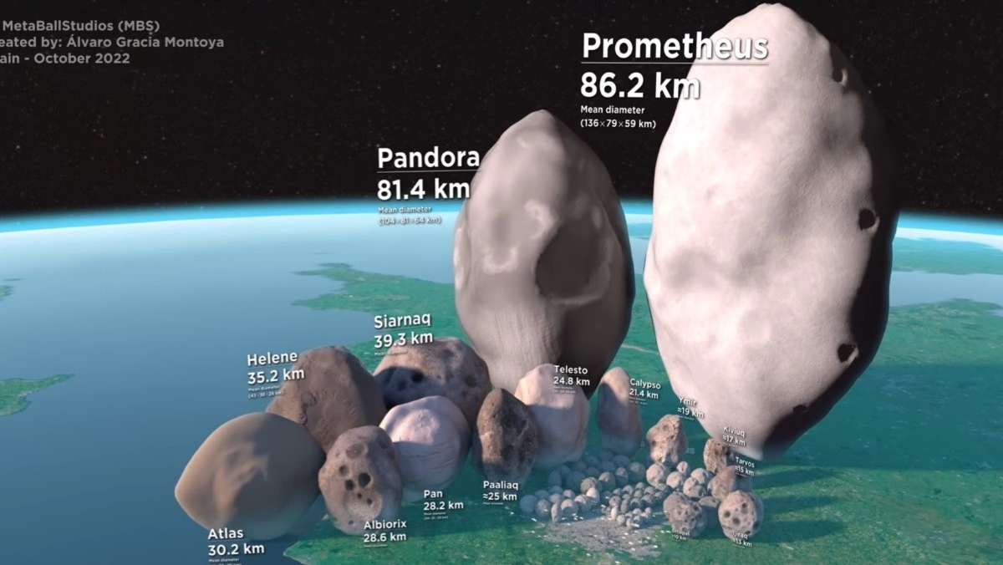
Saturn’s Moons’ Size Comparison scaled to Earth’s surface.
Answers: 1. The phases and eclipsing of the Moon; 2. Discovery of Jupiter’s moons by Galileo; 3.Viewing the Moon’s surface with telescopes; 4. Gravity and the universal law of gravitation; 5. Earth’s Moon and the moons of Uranus that are perpendicular to the ecliptic plane; 6. Moon’s large angular momentum and mass ratio cannot be explained and its orbital plane differs both from the ecliptic plane and the Earth’s equatorial plane; 7. The capture mode for this two-body problem is impossible due to gravitational laws and calculus; 8. The Giant Impact hypothesis; 9. The Earth remained hydrated, Earth rotation did not increase, the Moon’s orbital plane does not match Earth’s equatorial plane, and the large angular momentum of the Moon is a mystery among numerous other reasons; 10. Yes, the Earth’s Metamorphosis Hypothesis; 11. Collisions or breaking apart inside a planet’s Roche Limit and/or the sputtering of planetary surfaces by high energy discharge arcing of plasma currents (controversial); 12. Comet Shoemaker-Levy 9 into Jupiter in 1994; 13. The outer planets are our solar system’s trash collectors.

