Astrophysics Quiz No. 17: What Do the Asteroids Tell Us?
- What asteroid-type object is considered both an asteroid and one of the dwarf planets which are gravitationally rounded? ___________________._
- Most asteroids become more irregular in shape especially as they become increasingly smaller than 300 km (186 miles) in diameter. They range in size from 525 km to 1 km. Most of the smaller bodies are clustered around a size of about _________.
- The main-belt asteroids span an orbiting flat disk ranging between the inner edge of ______AU and the outer edge of _______ AU located between the orbits of Mars and Jupiter.
- The total mass of the asteroids is typically compared to be close to but less than what celestial body? _____________.
- What are the three chief classifications? A. Main-belt; B. Comets; C. Trojans; D. Kuiper Belt Objects; E. Near Earth Objects.
- Asteroids are divided into 3 main types: C-type, S-type, and M-type. What do the letters stand for? _____________________________________.
- What asteroid type is the most common with its meteorites having organics and amino acids? ___________. Also, this type theoretically caused the dinosaur extinction 65 million years ago.
- What is the rationalization for igneous or basaltic (volcanic) rock found on the surfaces of asteroids? ____________________________________.
- The first theory for the creation of the main-belt asteroids was a large collision between two planet-size bodies occurring between Mars and Jupiter. What is the theory called and why did it fall out of favor? ____.
- A recently fallen meteorite was discovered to have carbonates, but carbonates require within the realm of our knowledge what three ingredients? ______________________________________________.
- How does consensus science explain that the earliest solar system materials of dust and small planetesimals have – organics and ammino acids for initiating life; volcanic rock from bodies not large enough to support hydrostatic equilibrium; and carbonates requiring liquid water that should have been boiled away during the hot T-Tauri phase of the protostar? ____.
- How does consensus science explain why the asteroid belt does not comply with the accretion theory and its ongoing accretion over the past four billion years? ___________.
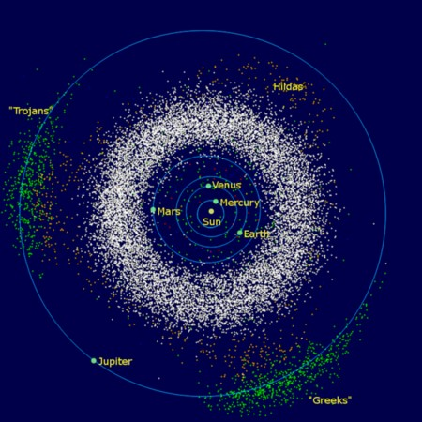
Distribution of Asteroids in the Inner Solar System

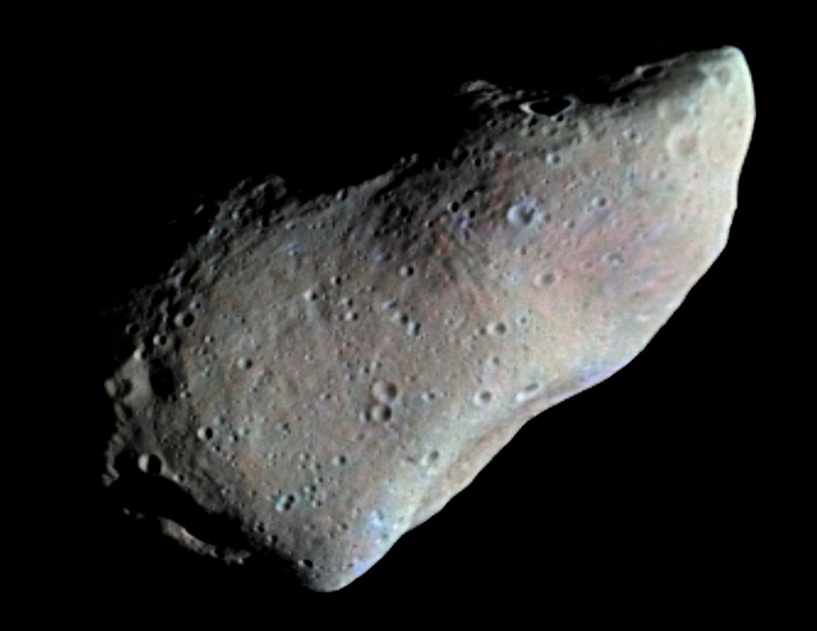
First Asteroid Imaged by Spacecraft - Gaspra
Answers:
- Ceres
- 1 km or 0.6 miles
- 2 AU, 3 AU
- Earth’s Moon
- A, C, and E
- chondrite, stony, and metallic
- C-type or chondrite
- Iron sinks to the center forcing lava upward due to hydrostatic equilibrium; however, such required gravitational forces can only occur on the few larger bodies such as Vesta and Ceres
- The Disruption Theory and remnants of the colliding planets were never found.
- Liquid water, CO2, and a solid, rocky surface for its formation.
- There are no consensus explanations.
- Jupiter’s nearby large gravity field causes perturbations and prevents any accumulation of the main belt asteroids which is only theorized.

