Astrophysics Quiz No. 20: General Trends for the Creation of the Chemical Elements
- What is the maker of heavier elements between helium and iron?
a. The Big Bang
b. Stellar Nucleosynthesis
c. Supernovae
d. Artificially synthesized.
2. What does stellar nucleosynthesis require for its operation per consensus
science?
a. Gravity
b. Thermal expansion from nuclear fusion
c. Millions of years
d. All the above.
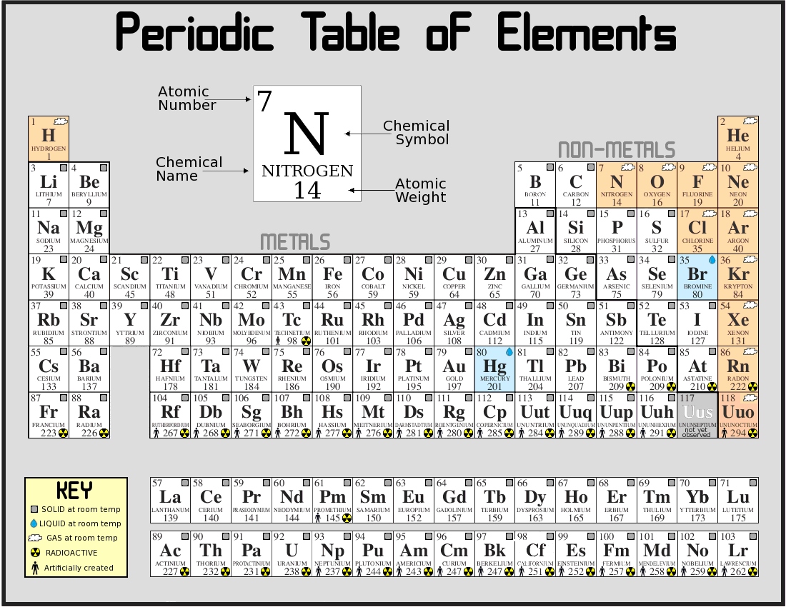
3. Which general trends for elements are true?
a. Hydrogen and helium are the most common elements from the
Big Bang nucleosynthesis.
b. The next 3 elements; Li, Be, and B are rare being poorly
synthesized in Big Bang and stars.
c. Alternation of abundance according to whether they have even or
odd atomic numbers.
d. General decrease in abundance as elements become heavier,
except in the region of iron and nickel.
e. All the above except c.
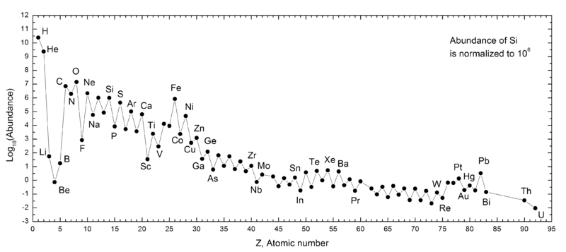
Abundances of Chemical Elements
4. From the logarithmic graph the most abundant elements after H and He are:
Carbon-C, nitrogen-N, oxygen-O, neon-Ne, aluminum-Al, magnesium-Mg, silicon-Si, sulfur-S, iron-Fe, nickel-Ni, and calcium-Ca. These elements mostly compose what celestial objects of the solar system listed below?
a. Rocks found on the terrestrial planets
b. Rocks found on the Moon
c. The Sun
d. Asteroids
e. Moons of outer planets
f. Jupiter and Saturn
Answers: 1. – b; 2. – d; 3. – a, b, c, and d; 4. – a, b, d, and e.

