Astrophysics Quiz No. 21: How did the elements and molecules find their final residence in the solar system? This question is not easily answered.
- Major constituents of volatiles of solar system solid bodies are H, He, N, O, and C and make-up the most abundant molecules which are:
a. H₂0, CH₄, CO₂, NO_{n}, SiO_{n}, & NH₄.
b. The isotopes of hydrogen and helium.
- Massive Population III stars keep exploding in the very early universe and eventually divide into many medium size,Population II stars creating elements of higher atomic numbers or metallicity. How do astronomers identify our star, the Sun?
a. As a long-lived yellow dwarf star
b. Population I, with the highest metallicity
c. As a medium size Population II star with medium metallicity
d. As a several- generation star that gathered higher metals from previously exploded stars via large molecular clouds in the interstellar medium.
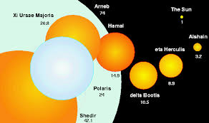
Scale of Largest Known Stars
- Due to their creation by the continuing explosion of larger short-lived stars, what are the most observable objects in the universe?
a. Asteroids and comets
b. Galaxies
c. Dwarf stars and planets
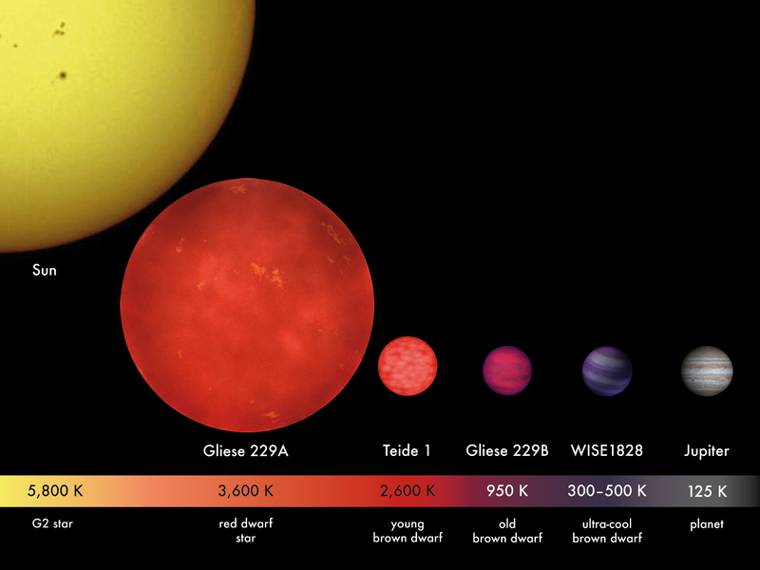
Population I stars, with the highest metallicity
- All the major constituents of the planets come from the elements of stellar nucleosynthesis which is what percentage of the total mass of the solar system?
a. 5 % b. 2.5 % c. 0.1 %
- If the entire solar system is made from the same interstellar cloud, why is the composition of the planets and the Sun so different?
a. The early protostar after reaching ignition keeps drawing inward denser, more solid elements and minerials while pushing away via solar winds the lighter volatile elements toward the outer solar system.
b. As the protostar disk pulls inward, denser elements become striated due to unknown mechanisms into concentric rings which will eventually coalaece into planetary cores that then begin to draw inward surrounding volatiles to form the gas and ice giants.
c. The larger bodies such as the Sun and outer planets become unequally charged bodies that then are forced to disgorge high density materials from their equatorial planes to reach charge equilibrium. The high density materials come from the interstellar cloud, but mostly from the star’s extremely hot corona that fuses various atomic nuclei that then sink to the body’s core to create unequilibrium of charge such as happens in a man-made Z-pinch in plasma laboratories.
d. Only weak ideas exist within consensus science and are disputed in such forums as Quora, Reddit, and Astronomy StackExhange.com. and a persistence of a zealous resistance to an electrical hypothesis.

Answers: 1. – a; 2. – a, b, and d; 3. – c; 4. – c; 5. - d

