**Astrophysics Quiz No. 24: How did the heavy elements become distributed in our solar system? (Part 1)**

1**.** According to the nebular hypothesis the proto-stellar disc was composed of all the heavy chemical elements that were –  
a. Located in various concentric rings about the forming star.  
b. Uniformly distributed about a radial distance from the new star.

2. After planetary formation, the net outcome was that the inner planets had a _________fraction of the heavy elements than the outer bodies.  
a. Lower  
b. Higher

3. The only solids forming in the Inner Solar system were the heavier elements such as iron, silicon, and magnesium. These elements formed with another abundant heavy, relatively reactive element, __________, to form silicates and other minerals. The lighter elements such as hydrogen and helium are boiled away because of the _____________.  
a. Carbon, protostar’s hot corona  
b. Oxygen, surrounding temperatures within 2 or more AU were very hot.

4. The lighter or more volatile solids such as water, carbon dioxide, ammonia, and methane required cooler conditions to form as solids and for this reason were found in smaller bodies mostly beyond __________.   
a. Earth’s orbit  
b. Mar’s orbit  
c. The snowline (or frost line)

5. It is strongly proposed that the gas giants collected most of the gases because they had the advantage of quickly forming larger cores of both rock and different ices due to their more isolated location. Hence, Jupiter and Saturn gathered gravitationally most of the surrounding hydrogen and helium which came from ________________.  
a. Only the surrounding orbital region  
b. From both the orbital region and solar winds driving gases outward from the star.

6. The giant gas planets have an overall abundance of elements quite similar to the _______________.

a. Interstellar medium  
b. Original solar nebular  
c. Sun itself

7. The less massive ice giants, Uranus and Neptune, formed differently because-   
a. the environment for solar wind gases was disrupted by the gas giants.  
b. the primordial disk was dissipated before their smaller cores could gather enough of the lighter gases.  
c. their longer orbits took more time to collect a similar amount of gases as did the smaller orbits of the gas giants.

8. Even though the overall fraction of heavy elements is low, the predicted solid cores of Jupiter and Saturn have -  
a. solid hydrogen  
b. 10 to 20 Earth masses of rocky/icy material

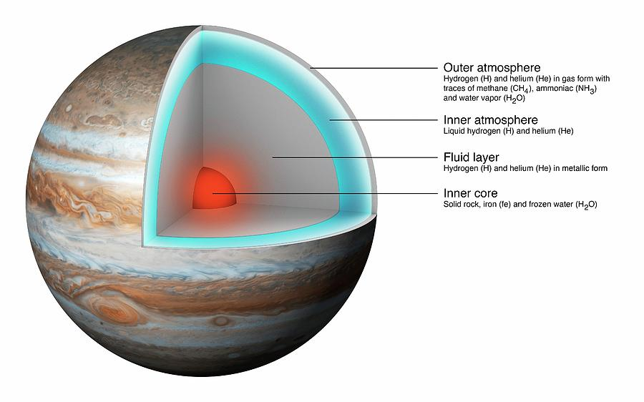

*The reader may have different opinions about how the elements were distributed which also differs from consensus science. I would be interested in your version of how things occurred. Contact me at* [dougettinger@verizon.net](mailto:dougettinger@verizon.net).

**Answers: 1. b; 2. b; 3. b; 4. c; 5. b; 6. b and c; 7. a, b, and c; 8. b.**