**Astrophysics Quiz No. 25: How did the heavy elements become distributed in our solar system? (Part 2)**

1. What problems does the popular nebular hypothesis pose if materials were fairly well distributed in the beginning?  
a. Presently, the heavy elements are very unevenly distributed throughout the solar system without knowing a plausible mechanism.  
b. The theory of accretion via random collisions and gravitational attraction of smaller accumulations becoming increasingly larger does not address that only one body for each well-distributed discrete orbit was created.  
c. Only one planetary core was created as opposed to many for each orbit and subsequent collisions would create collisional debris rather than one object.

2. The Main Belt of asteroids never accreted over billions of years as supposedly the planets achieved in their respective orbits. What excuses do consensus scientists give for this phenomenon?  
a. An early collision occurred wherein the temperature conditions were no longer adequate for partially molten states to stick together - at about 2.7 AU from the Sun.  
b. The gravity fields of the nearby giant gas planets of Jupiter and Saturn created perturbing resonances due especially to their periodic conjunctions.  
c. Once a significant collision occurred that dispersed the pieces far enough, there were no forces large enough to recombine these materials.

3. What reasons do the Main Belt of asteroids negate the popular nebular hypothesis?  
a. These smaller bodies never accreted into one large discrete body as did the existing planets.  
b. Due to space probe exploration findings these asteroids are not composed of the theorized original star dust that made up the solar disk that formed the protostar.   
c. A typical asteroid is composed of igneous-type rock and carbonates that could compellingly only come from an early planet that already differentiated into a silicate mantle covered with a sufficiently cooled crust that had condensed liquid water on its surface.

4. So if planets did not accrete from orbiting rings of heavy elements in the solar disk, then how were they possibly created? Which idea among numerous has not been rejected yet on the grounds of known physics?  
a. Captured gravitationally from surrounding interstellar space.  
b. A collision of two stars that created globular materials to be ejected and then captured gravitationally.  
c. The young forming protostar electrically discharges equatorially various planets of various compositions and sizes due to charged particle separation similar to observed coronal mass ejections, but much more robust during the “T-Tauri phase” of formation.  
c. Molten material is pulled away due to centrifugal force of an abnormally high spinning star that is then gravitationally captured into an orbit without achieving escape velocity.

August 18, 1980: White Light image by High Altitude Observatory.

A coronal mass ejection in April 2023 caused Earth to grow Alfvén wings. (This CME, with Earth illustrated to scale, took place in 2021.) Credit: [NASA/GSFC/SDO](https://svs.gsfc.nasa.gov/11078) (See below)

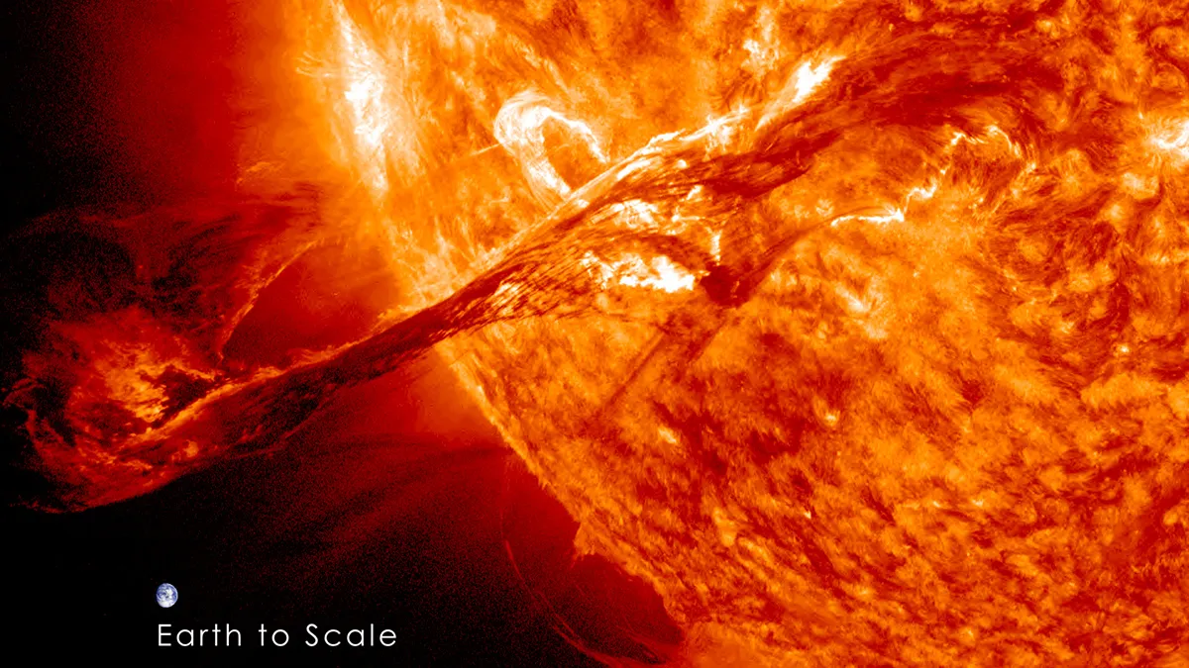

**Answers: 1. a, b, and c; 2. b; 3. a, b, and c; 4. c.**