Astrophysics Quiz No. 28: Learn More About Nature Closer to Home: Our Fantastic Earth with its Carbon and Nitrogen Cycles necessary for human life and not found anywhere else in the solar system. (PART 2)
1. What human activities are directly involved in the Nitrogen Cycle?
a. Burning of fossil fuels.
b. Decomposition of dead animals and plants.
c. Over-use of nitrogen-rich fertilizers in agriculture that may cause undesirable nutrient loading of waterways.
2. What harmful effects are caused by humans within the Nitrogen Cycle?
a. Acid rain that kills forests and comes from the emissions of automobiles and industrial combustion.
b. Adding to the greenhouse gases to partially cause reputed global warming.
c. Air pollution and smog that is harmful to human health.
3. How is nitrogen in the atmosphere directly and naturally absorbed into the biosphere?
a. Conversion to ammonia (NH3) by nitrogen fixation of certain plant bacteria.
b. Conversion to nitrites (NO2 -) and nitrates (NO3 -) by nitrifying bacteria.
c. By lightening which breaks nitrogen into nitrogen oxides which are then used by plants.
4. How do plants and animals absorb nitrogen?
a. Plants assimilate nitrates from the soil which need to be constantly replaced to support adequate growth for commercial agriculture.
b. Animals absorb nitrogen from plants they eat.
c. Plants absorb N2 directly from the atmosphere.
d. Plants absorbing N2 from human-made fertilizers and cow manure.
5. How is nitrogen re-introduced into the atmosphere?
a. From the release of nitrogen from ammonia salts (NH4 +).
b. By emissions from burning fossil fuels for transportation and generating electricity.
c. The reduction of nitrates (NO3) and nitrites (NO2) by certain plants called denitrifiers causing the release of N2.
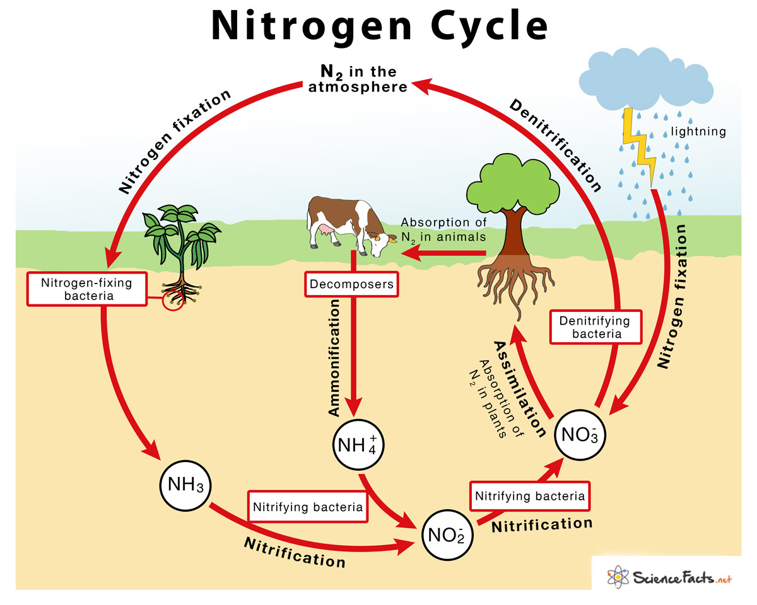
6. Why isn't the accumulation of the dangerous poisonous gases of CO and NO emitted by cars, trucks, and power generation plants considered dangerous?
a. These poisonous gases are inconsequential when mixed into the huge reservoir of the planet’s atmosphere.
b. These gases become re-absorbed via the nitrogen cycle.
c. When NO and CO are released into the atmosphere they quickly combine with oxygen in the air to form NO2 and CO2.
If you find any errors, please inform me at dougettinger@verizon.net. Thanks.

Answers: 1. a and c; 2. a, b, and c; 3. a and c; 4. a, b, and d; 5. c; 6. c.

