**Astrophysics Quiz No. 29: Try identifying the following objects or major past events of our solar system.**

**1. _____________________________________________________**

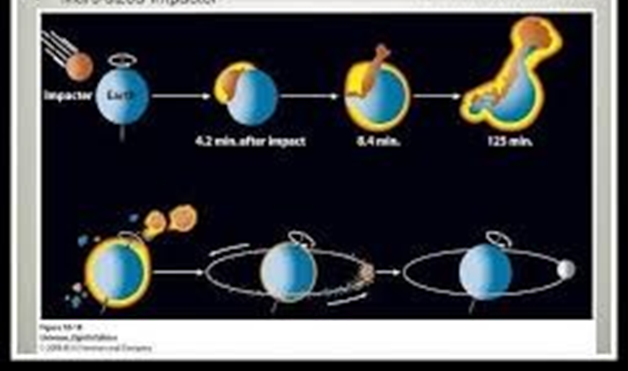

**2. ___________________________________________________**

**3. _____________________________________________**

**4. _____________________________________________**

**  
5. _____________________________________________**

**Answers: 1. Stages of NASA’s Giant Impact Hypothesis; 2. Moons of Saturn shown to scale with Earth; 3. 351 Gaspra Asteroid photographed by space probe; 4. Orion Constellation diagram; 5. Callisto, the second largest Moon of Jupiter.**