**Astrophysical Quiz No. 31: Understanding Variable Star Systems**

[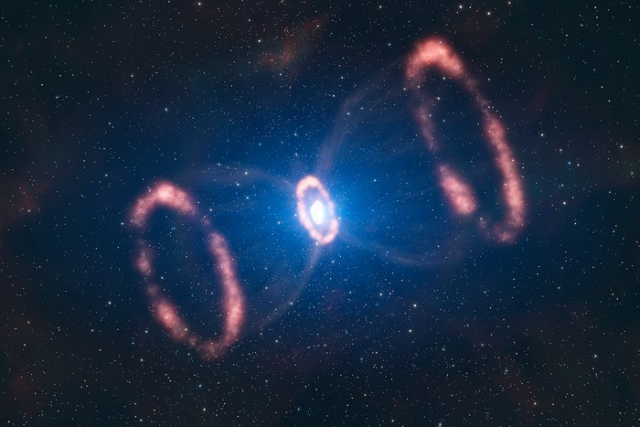](https://d.docs.live.net/D3C300D5F3C9DC78/Documents/Astronomy%20and%20Astrophysics%20Quizes)

The above artist’s illustration is a supernova that occurred in our galaxy system.

1. What is its name? a. SN 1998 B; b. SN 1985 C; c. SN 1987 A
2. In what region did this explosion occur? a. Within the one of the spiral arms of the Milky Way; b. Inside the Large Magellanic Cloud; c. inside the Small Magellanic Cloud.
3. Can a supernova be observed in a distant galaxy? a. Yes; b. No.
4. What distinctions did this supernova have? a. This supernova is the closest ever observed; b. Its expulsion was symmetrical about the center; c. Its expelled material was concentrated more in one direction; d. the exploding star showed two rings of expelled material.
5. The original star was identified as Sanduleak (SK-69-202) which was - a. Neutron star; b. White dwarf; c. Blue supergiant.
6. This supernova was estimated to be a distance of – a. 48,000 light years (lys); b. 2 million lys; c.168,000 lys.

1. The Crab Nebula is a supernova remnant that occurred in – a. an unknown time; b. 1066 AD; c. 1054 BC; d. 1054 AD.
2. The center of this nebula has – a. black hole; b. neutron star; c. spinning pulsar; d. no remaining mass.
3. This nebula can be located – a. 10 light years distant; b. in the constellation of Virgo; c. in the constellation of Taurus; d. near the edge of the Milky Way galaxy.
4. These light curves below represent what kind of variable stars? a. Binary star; b. Cepheids; c. eclipsing white dwarfs.

**Answers:**

1. **c; 2. b; 3. a; 4. a, c, and d; 5. c; 6. c; 7. d; 8. b and c; 9. c; 10. a and b.**