Astrophysics Quiz No. 27: Learn More About Nature Closer to Home: Our Fantastic Earth with its Carbon and Nitrogen Cycles
1. If the majority of CO2 were removed from the atmosphere what natural major things would occur?
a. Most plant life and the ocean’s biomass would perish because plants take in CO2.
b. Oxygen levels in the atmosphere would be dramatically reduced thereby suffocating or causing oxygen deprivation for humans and other animals.
c. Elimination of this greenhouse gas would reduce average global temperatures to about 18 degrees Fahrenheit which would be inhospitable for most life.
d. The Earth would become cooler and reduce the growing season at higher latitudes leading to starvation in many regions.
2. How many major greenhouse gases exist besides CO2?
a. Only water vapor and clouds.
b. No other gases are significant greenhouse gases.
c. Methane, nitrous oxide, and water vapor
3. What produces the most CO2 that is emitted into the atmosphere?
a. Air-ocean exchange via respiration and decomposition.
b. Human industrialized emissions estimated at 9 gigatons of carbon per year taken from the US DOE Biological and Environmental Research Info. System.
c. Plant and animal respiration.
d. Land microbial respiration and decomposition.
e. Volcanoes
4. What processes do greenhouse gases perform on planet Earth?
a. Completely trap all the solar energy inside the atmosphere.
b. Allow both incoming energy to strike Earth and reflect outgoing energy to escape into space.
c. Reflect energy from the top of the atmosphere.
5. What process absorbs the most CO2 from the atmosphere?
a. Photosynthesis of plant and ocean biomasses.
b. Ocean coral, seashells, and other sea animals.
c. CO2 keeps increasing with very little chemical reaction or absorption.
d. Natural production of crustal fossil carbons such as coal, oil, and natural gas.
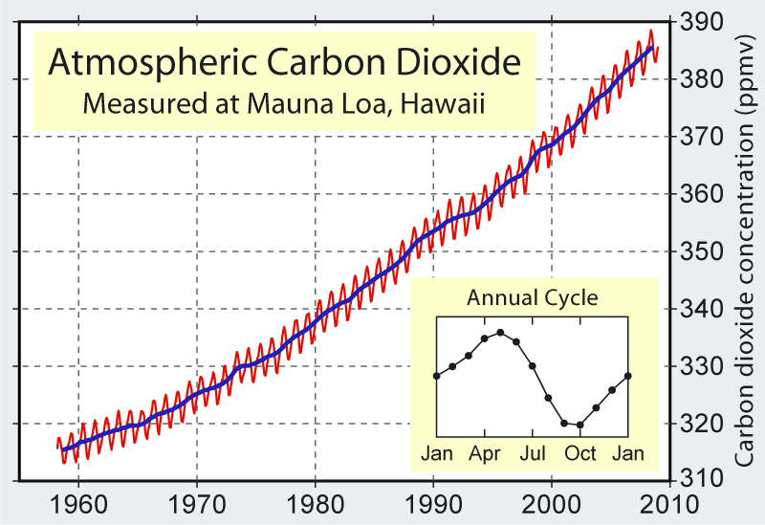
6. The above diagram shows measured CO2 increasing since its inception in 1958. Why are humans and other animals not being poisoned by this gas?
a. Scientists claim that this gas is being produced by burning fossil fuels that cannot be absorbed completely by the land and ocean sinks. Hence, the calculated atmospheric growth of 4.3 gigatons per year is supposedly causing global warming and severe climatic changes which have not yet reached the fearful proportions of a Venusian atmosphere. The added CO2 is only 0.0016 % of the total atmosphere which is seemingly minute to cause poisoning.
b. The measurements do not represent an adequate baseline since ice core air bubble concentrations of CO2 are required in previous years and centuries. Hence, the perceived alarming increase in CO2 concentration may be misleading, and global warming or cooling could have other natural causes such as the Milankovitch cycles.
c. Perhaps the scientists are being overdramatic looking for some direct causation. The increase of about 100 parts per million by volume over 100 years represents a minuscule change of 0.0016 % of the present total atmospheric CO2 volume.
The diagram below is the Global Project Carbon Budget presented in 2017 by the University of New Hampshire, Charles University, and the Globe Program. The numbers do not necessarily come from empirical data, but more likely from computerized extrapolations. What is not shown is that the burning fossil fuel emissions are only postulated to be re-absorbed by about 50% thereby growing yearly the CO2 volume by about 4.3 gigatons. I find this conclusion about our breathing Earth not extraordinarily worrisome and amazingly suspicious of fearing. Can you trust the experts, most of whom are funded by the government? When applying for grants a scientist must understand what answer the government expects if he desires funding.
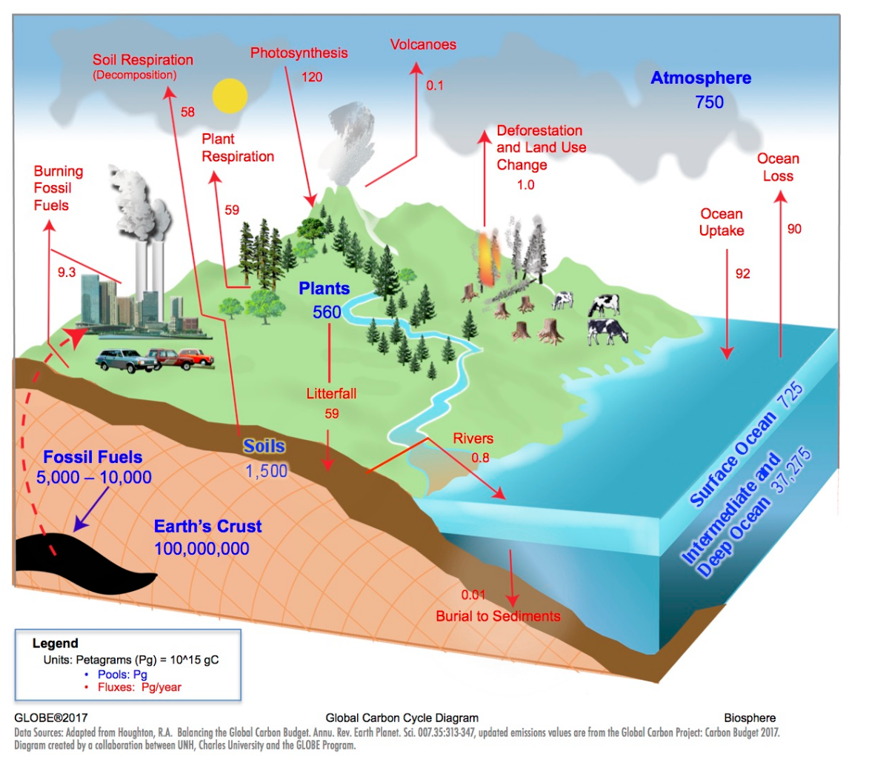
Answers: 1. a, b, c, and d; 2. c; 3. a; 4. b and c; 5. a; 6. a, b, or c (make your choice – the global-warming alarm may be partially a political contrivance and motivation).

